COVID-19 response
Melbourne criminal jury trials where no physical distancing required – guide for the profession and court users

DOCUMENT CONTROL
Details
Document type | COVID-19 response
Reference | Melbourne criminal jury trials where no physical distancing required – guide for the profession and court users
Division | Criminal Division
Authorised by | His Honour Judge Mullaly, Head of the Criminal Division
Notes | This Guide applies when density quotients and physical distancing are not required in the courtroom or spaces used for jury trials.  If density quotients, physical distancing and any other health and safety measures are re-introduced, the County Court will seek expert health advice and may suspend the procedures in this Guide and introduce alternative procedures, where required.
Release history
Version | Date | Author | Summary of changes
1.0 | 21/5/2021 | Winnie Wang, Criminal Division Senior Administrator | See ‘Notes’ section above.
2.0 | 11/6/2021 | Winnie Wang, Criminal Division Senior Administrator | Includes mask settings 1–3. Implements new process where jurors will be asked to select and carry with them two additional masks before being brought up to the trial courtroom (additional masks to be used where a juror may be required to remove and dispose of a mask during the taking of excuses or during the empanelment of the jury and parade). Clarifies the point at which jurors should put their mask back on after the taking of excuses, challenge/stand aside or after being selected as a juror.
3.0 | 9/7/2021 | Winnie Wang, Criminal Division Senior Administrator | Includes the requirement for all trial participants to sign in using the QR code digital system each time they enter the Court building, updated health screening questions, updated information on testing and clarification regarding mask setting 3.
4.0 | 4/8/2021 | Winnie Wang, Criminal Division Senior Administrator | Includes an update to the guidelines if a trial is impacted by COVID-19.
5.0 | 24/11/2021 | Winnie Wang, Criminal Division Senior Administrator | Includes updates to the guidelines if a trial is impacted by COVID-19, and health and safety measures. Also includes measures relating to COVID-19 vaccination for jurors and trial participants.
CONTENTS
1. Melbourne criminal jury trials 5
Application of guide 5
Criminal trial process 5
COVID-safe health and safety overlays principles 5
Mutual obligations to health and safety 5
Related documents and appendices 6
2. Juries Victoria measures 7
COVID-19 information for jurors 7
Applications for excuse or deferral 7
Juries Commissioner’s power to exempt 7
Jury pool 8
3. General information 8
COVID-19 vaccination protocol 8
Masks 8
Mask setting 1: mask-wearing by all trial participants 9
Mask setting 2: mask-wearing by non-speaking participants 10
Mask setting 3: mask-wearing not required for trial participants save for limited circumstances (during empanelment) 11
Mask setting 4 11
Court-provided disposable masks 11
Disposable gloves 12
Cleaning 12
Juror daily health screening questions 12
QR codes 13
Expedited testing protocol 13
4. Pre-trial matters 13
5. Jury empanelment 14
Jury empanelment procedure 14
6. The jury trial in court 19
7. Guidelines if a trial is impacted by COVID-19 25
(a) Trial participant associated with tested person 25
(b) Trial participant tested (Suspected case guide) 27
(c) Trial participant tests positive (Positive test guide) 33
APPENDIX 1: Hand washing protocol 36
APPENDIX 2: Safe use of hand sanitiser protocol 37
APPENDIX 3: Safe mask use and disposal protocol 38
APPENDIX 4: Safe glove use and disposal protocol 39
APPENDIX 5: Safe use of face shield protocol 40

Melbourne criminal jury trials

Application of guide
  - This Guide applies when there are no density quotient and physical distancing requirements in courtrooms or spaces used for jury trials.
  - If density quotients, physical distancing and any other health and safety measures are re-introduced, the County Court will seek expert health advice and may suspend the procedures in this Guide and introduce alternative procedures, where required.

Criminal trial process
  - The pre-COVID criminal jury trial process will be adopted in so far as possible, but with the necessary COVID-safe overlays outlined in this Guide.
  - The pre-COVID criminal jury trial process means:
    - The Court will use in-person jury pools.
    - The jury panel will be brought up to the trial courtroom and empanelment will take place in-person in the trial courtroom. This means there will be no remote empanelment from the jury pool room.
    - Each courtroom’s adjoining jury room will be used by the jury during adjournments and deliberation and a paired courtroom will not be required.

COVID-safe health and safety overlays principles
  - The COVID-safe health and safety measures and overlays that remain are intended to comply with the Court’s duty under the Occupational Health and Safety Act 2004 (Vic) to ensure, so far as is reasonably practicable, the health and safety of judicial officers, staff, jurors and court users by:
    - eliminating risks to health and safety so far as is reasonably practicable
    - where it is not reasonably practicable to eliminate risks to health and safety, to reduce those risks so far as is reasonably practicable.
  - The measures outlined in this Guide are specific to jury trials.

Mutual obligations to health and safety
  - All participants in the jury trial will be apprised of, and where required appropriately reminded of, the mutual obligations of all participants to the health and safety of one another.
  - For example:
    - Jurors will be instructed that they have a responsibility to stay at home if they are unwell and not place the health and safety of judicial officers, court staff and other court users at risk.
    - Jurors will be instructed that they have a responsibility to stay at home if they are unwell and not place the health and safety of judicial officers, court staff and other court users at risk.
    - All trial participants, including judges, court staff, jurors, counsel, practitioners, witnesses and any other persons permitted in the courtroom are not to attend the Court if they:
- feel unwell, or have any signs or symptoms of COVID-19
- are awaiting test results for COVID-19
- are required, or anyone they live with is required, by public health authorities to take a COVID-19 test OR to stay at home in quarantine or isolation.
  - Legal practitioners, on behalf of each party, must advise the Court if they are aware any trial participant feels unwell or has signs or symptoms of COVID-19, are awaiting test results for COVID-19 or are required, or anyone they live with is required, by public health authorities to take a COVID-19 test OR to stay at home in quarantine or isolation.
  - Parties should contact the chambers of the presiding judge if a trial participant is unable to attend due to any of the reason(s) outlined in paragraph 1.8. The judge will decide the future conduct of the matter which may include alternative remote appearance arrangements or an adjournment.

Related documents and appendices
  - This guide should be read in conjunction with the following documents:
    - Hand washing protocol (see Appendix 1)
    - Safe use of hand sanitiser (see Appendix 2)
    - Safe mask use and disposal protocol (see Appendix 3)
    - Safe glove use and disposal protocol (see Appendix 4)
    - Safe face shield use and disposal protocol (see Appendix 5)
    - Court Service Victoria COVIDSafe Plan
    - Jury trial vaccination protocol
    - Personal protective equipment (PPE), movement and testing protocol

Juries Victoria measures

COVID-19 information for jurors
  - Jurors will be asked to check the Juries Victoria website for information about the precautionary measures and guidelines for their attendance.
  - The Juries Victoria website includes advice that jurors are not to attend the Court, and must call Juries Victoria, if they:
    - feel unwell, or have any symptoms of coronavirus (COVID-19)
    - are awaiting test results for COVID-19
    - are required, or anyone they live with is required, by public health authorities to take a COVID-19 test OR to stay at home in quarantine or isolation.

Applications for excuse or deferral
  - In addition to the more commonplace reasons for deferral (such as pre-booked leave, small business ownership, etc.) Juries Victoria will give greater consideration to excusing or deferring persons who may be particularly vulnerable to the consequences of COVID-19, or who, for example, would have difficulty complying with the requirement to wear a mask, or have issues with providing consent or undergoing a COVID-19 test if required.

Juries Commissioner’s power to exempt
  - The Juries Commissioner may exempt a person or class of persons from being summonsed for jury service if, in the Commissioner’s opinion, there is good cause to do so based on health, safety or welfare concerns relating to the person, that class of persons or the community.
  - Having formed the opinion there is a good cause to do so based on health, safety and welfare concerns relating to the class of persons and the community, pursuant to s 27(4) of the Juries Act 2000, the Juries Commissioner has exempted the following class of persons from being summonsed for the period 26 November 2021 to 11 February 2022:
    - Persons who have not been fully vaccinated against COVID-19 excluding persons who provide an Australian Immunisation Register immunisation medical exemption form that is completed and signed by the person’s medical practitioner and states that the person is unable to receive a does or a further dose of a COVID-19 vaccine due to a medical contraindication or an acute medical illness; and
    - Persons who fail or refuse, prior to the date they are required to attend for jury service or immediately upon attending for jury service, to provide either satisfactory evidence of being fully vaccinated or an Australian Immunisation Reiser immunisation medical exemption form that is completed and signed by the person’s medical practitioner and states that the person is unable to receive a dose or further dose of a COVID-19 vaccine due to a medical contraindication or an acute medical illness.
  - If a person, or class of persons, has a medical exemption from vaccination, the Juries Commissioner may provide that person with an opportunity to serve, defer their service or be excused or exempted from jury service.

Jury pool
  - Up to 150 jurors may be assembled in-person in the jury pool room to provide jury panels.
  - While the pre-COVID process allowed up to 150 people to be brought in to form the jury pool, lower numbers may be brought in on any given date depending on the number of empanelments that occur on the same day, estimated trial length and number of accused in the trial.
  - As the Court reverts back to jury pools and in-person jury panels, the Court will monitor jury pool sizes, the number of empanelments that can occur on any one day and the time at which empanelment can proceed (that is, when a jury panel seated in the trial courtroom is ready for empanelment).

General information

COVID-19 vaccination protocol
  - As an additional measure of safety, the Court has implemented a Jury trial vaccination protocol and Personal protective equipment (PPE), movement and testing protocol which will apply to all criminal jury trials unless otherwise advised by the Court.
  - The Court’s approach to risk assessment takes account of the particular operational requirements of the County Court, including the volume of jury trials which will be conducted at the Court on a daily basis and the corresponding number of people in attendance.
  - Against that background, the Court is obliged to take all practicable steps to reduce the COVID-19 health risks to all participants in the jury trial environment and to reduce the prospect of disruption. This must be balanced against the need to ensure that the interests of justice are served.
  - One practical and effective way to do this is to keep the presence and mixing of unvaccinated trial participants in the courtroom trial environment to the absolute minimum, especially with respect to those persons who play a central, ongoing and speaking role in the trial.
  - The Jury trial vaccination protocol and Personal protective equipment (PPE), movement and testing protocol outline the Court’s approach to jury trials where there may be vaccinated and unvaccinated trial participants.
  - All trial participants including legal practitioners, should refer to the Court’s Jury trial vaccination protocol and Personal protective equipment (PPE), movement and testing protocol for further information.

Masks
  - The Court’s requirement for trial participants to wear masks is described by the following settings:
    - Mask setting 1 – mask-wearing by all trial participants is required
    - Mask setting 2 – mask-wearing by non-speaking participants is required and opening and closing addresses made from the end of the bar table
    - Mask setting 3 – mask-wearing is not required for trial participants save for limited circumstances (during empanelment only)
    - Mask setting 4 – mask-wearing is not required for trial participants but may be worn voluntarily (save for circumstances where removal is required).
  - These requirements are subject to any additional requirements provided for by the Jury trial vaccination protocol and Personal protective equipment (PPE), movement and testing protocol.
  - The appropriate setting will be determined by health advice, and the Court will publish advice, on an ongoing basis, as to the setting that is currently in effect.
  - The chambers of the presiding judge will also advise parties of the setting prior to the commencement of a trial, and during a trial should the setting change.

Mask setting 1: mask-wearing by all trial participants
  - Where health advice requires mask-wearing by all participants, all trial participants (judges, court staff, jurors, counsel, practitioners, witnesses and any other persons permitted in the courtroom) will be required to wear masks – including when speaking – save for in the following limited circumstances:
    - the accused will be required remove their mask when pleading during the arraignment
    - a juror may be required to briefly move their mask to one side, while holding the straps, during the callover and answering ‘Present’ or ‘Excuse’
    - a juror may be required to remove their mask when addressing the Court during the provision of any verbal excuse, or when addressing to the Court regarding a written excuse
    - a juror will be required to remove their mask during the empanelment of the jury and the parade
    - an in-person witness will be required to remove their mask when being sworn in and for a short period thereafter – as determined by the judge – for the purposes of identification
    - an in-person witness may be required to remove their mask for short periods – as determined by the presiding judge – to facilitate the assessment of the witness’ credibility, during which period a face shield will be worn (see Appendix 5).
  - Any witness appearing remotely is not required to wear a mask while giving evidence.
  - Court staff will not be required to remove their mask at any time, save for the brief period required for identification to the jury panel during empanelment (if this is the preference of the judge). Court staff will continue to wear a mask immediately thereafter.
  - Courtroom microphones will be set to provide a measure of amplification (not just recording) to reduce the need of any person speaking to project their voice.
  - Counsel and instructing solicitors will be requested to wear a disposable mask provided by the Court (using the Safe mask use and disposal protocol in Appendix 3) to allow for any removal and disposal during the empanelment process when trial participants are asked to identify themselves for the benefit of the jury panel.
  - While masks may be removed pursuant to the exemptions in paragraph 3.11 (a) – (f) while in court, court users must continue to wear masks when moving throughout the court facility.
  - During orientation, jurors will be provided information (including an instructional video) on the correct process for changing masks as required throughout the empanelment process and the trial.
  - If a person removes a mask, they must dispose of it in the bin provided and use hand sanitiser before selecting and fitting a new mask.
  - The Court will continue to monitor the circumstances and will seek ongoing health advice to determine if this setting is appropriate.

Mask setting 2: mask-wearing by non-speaking participants
  - Where health advice permits speaking participants to remove their masks, masks will be worn by all trial participants, save for in the following circumstances:
    - judicial officers and those speaking or addressing the court, including counsel and witnesses, may remove masks
    - the accused will be required remove their mask when pleading during the arraignment
    - a juror may be required to briefly move their mask to one side, while holding the straps, during the callover and answering ‘Present’ or ‘Excuse’
    - a juror may be required to remove their mask when addressing the court during the provision of any verbal excuse, or when addressing to the court regarding a written excuse
    - a juror will be required to remove their mask during the empanelment of the jury and parade
    - any witness appearing remotely, or in-person is not required to wear a mask while giving evidence (after giving evidence in-person, a witness must use hand sanitiser before selecting and fitting a new mask).
  - As an additional measure of comfort to the jury, counsel will be required to conduct any address to the jury from the end of the bar table furthest from the jury. The instructing solicitor may also move position to sit near counsel as they address the jury.
  - Counsel and instructing solicitors should move towards the centre of the bar table (if required) when the opposing counsel is addressing the jury.
  - Those addressing the Court may choose to continue to wear a mask so long as they can be clearly heard and understood, at the discretion of the judge.
  - Any witness appearing remotely is not required to wear a mask while giving evidence.
  - Court staff will not be required to remove their mask at any time, save for the brief period required for identification to the jury panel during empanelment (if this is the preference of the judge). Court staff will continue to wear a mask immediately thereafter.
  - Courtroom microphones will be set to provide a measure of amplification (not just recording) to reduce the need of any person speaking to project their voice.
  - Counsel and instructing solicitors will be requested to wear a disposable mask provided by the Court (using the Safe mask use and disposal protocol in Appendix 3) to allow for any removal and disposal during the empanelment process when trial participants are asked to identify themselves for the benefit of the jury panel.
  - While masks may be removed pursuant to the exemptions in paragraph 3.20 (a) – (f) while in court, court users must continue to wear masks when moving throughout the court facility.
  - During orientation, jurors will be provided information (including an instructional video) on the correct process for changing masks as required throughout the empanelment process and the trial.
  - If a person removes a mask, they must dispose of it in the bin provided and use hand sanitiser before selecting and fitting a new mask.
  - The Court will continue to monitor the circumstances and will seek ongoing health advice to determine if this setting is appropriate.

Mask setting 3: mask-wearing not required for trial participants save for limited circumstances (during empanelment)
  - Where health advice permits, the wearing of masks by all trial participants (including the judge, court staff, accused, counsel, instructing solicitors, witnesses, jurors) will be voluntary, and they will not be required to wear a mask (unless they wish to), save for during empanelment as follows:
    - During in-court empanelment, jurors will be required to wear masks while in the jury pool, in any public areas and while in the trial courtroom for empanelment (save for the points at which they are required to remove their mask – see paragraph 3.20 (c) – (e)). Jurors may remove their mask during the first adjournment after empanelment.
    - Trial participants will be required to wear a mask in any public areas.
  - Following empanelment, empanelled jurors are not required to wear a mask unless they wish to.
  - Trial participants are required to carry a mask with them at all times.
  - The Court will continue to monitor the circumstances and will seek ongoing health advice to determine if this setting is appropriate.

Mask setting 4
  - During mask setting 4, masks are not required to be worn by all trial participants.
  - Trial participants may wear a mask if they wish, subject to the following:
    - those addressing the Court may choose to continue to wear a mask so long as they can be clearly heard and understood, at the discretion of the judge
    - the accused will be required to remove a mask when pleading during the arraignment
    - a juror will be required to briefly move a mask to one side, while holding the straps, during any callover and answering ‘Present’ or ‘Excuse’ during empanelment
    - a juror will be required to remove a mask when addressing the Court during the provision of any verbal excuse, or when addressing to the Court regarding a written excuse
    - a juror will be required to remove a mask during the empanelment of the jury.
  - If a person requires a new mask, they must use hand sanitiser before selecting and fitting a new mask.
  - The Court will continue to monitor the circumstances and will seek ongoing health advice to determine if this setting is appropriate.

Court-provided disposable masks
  - Disposable masks will be available to all court users and those attending for jury duty and participating in a trial.
  - Jurors or trial participants arriving at the Court wearing their own mask (for example, a non-disposable mask) will be provided with a disposable mask by Juries Victoria staff, and asked to wear a disposable mask, to allow for ease of removal, disposal and for fresh mask(s) to be used throughout the empanelment process and trial. Jurors will be notified of this requirement by Juries Victoria staff in advance of their summons date.
  - Disposable masks will be available for jurors:
    - at entrance points before security screening
    - in the jury pool room
    - in the jury room.
  - Disposal bins and hand sanitiser will also be provided next to all masks distribution points to allow for safe mask use in accordance with the Safe mask use and disposal protocol (see Appendix 3).
  - In addition to the requirement that a new mask be worn whenever one is removed, on the advice that masks are to be refreshed every four hours, jurors and all court users will be provided with a fresh mask after any mid-sitting break if in mask settings 1 or 2 or if the juror wishes to wear a mask under mask setting 3 or 4 (see Appendix 3).
  - Supplies of additional masks and appropriate bins for safe mask disposal will be provided in the jury pool room, trial courtroom and the jury room.

Disposable gloves
  - Disposable gloves will be available to judges, court staff, legal representatives and jurors participating in a trial. The gloves will be available:
    - on the judge’s bench (for the judge)
    - on the judicial staff bench (for judicial staff and jurors)
    - on the Bar table (for legal representatives)
    - in the jury room (for jurors).
  - Hand sanitiser will also be provided next to gloves to allow for safe glove use and disposal in accordance with the Safe glove use and disposal protocol (see Appendix 4).

Cleaning
  - The Court has established an additional cleaning regime for the jury pool room, jury room, trial courtroom, deliberation area and jury bathroom with a focus on high touch points in areas used by multiple people. For example, high touch points in the witness box will be cleaned between witnesses.

Juror daily health screening questions
  - Upon entry to the Court building each day, jurors will be asked by a court security officer the following questions:
    - do you feel unwell, or have any symptoms of coronavirus (COVID-19)?
    - are you awaiting test results for COVID-19?
    - are you or anyone you live with required by public health authorities to take a COVID-19 test OR to stay at home in quarantine or isolation?

QR codes
  - In line with Victorian Government health directions and record-keeping obligations, all trial participants (including jurors, counsel, bailed accused, solicitors, and witnesses) must check in using the QR code digital system each time they enter the Court building. This includes if a trial participant leaves the building and returns on the same day for example, during lunchtime breaks.
  - If a trial participant does not have a mobile phone or other electronic device which enables them to electronically check in using the QR code, trial participants will be assisted to electronically check in using Court provided tablets.

Expedited testing protocol
  - The Court and Court Services Victoria have developed an expedited testing protocol which will facilitate the testing of any trial participant for COVID-19, and the receipt of results within 24 hours.
  - It is anticipated that a trial would be permitted to continue after a maximum adjournment of one day in order to facilitate the testing and receipt of the results.
  - Jurors will be advised in advance of attendance at court that they will be asked to consent to a testing protocol if selected as a juror, although completing the consent forms (and ultimately any testing) is voluntary.
  - Parties will be provided, in advance of the trial, with consent forms to complete (if they wish) and send to the chambers of the presiding judge for safe retention, in the event that expedited testing of counsel, instructing solicitors or witnesses is required.

Pre-trial matters
  - It is suggested that, in addition to the usual matters, counsel should assist the Court by addressing the following matters, if not already raised with the judge’s chambers:
    - confirming witness arrangements particularly with regard to those witnesses that will appear remotely using video links
    - whether an interpreter is required for the accused or any witness
    - whether a view is required
    - confirming with the Court the anticipated desire of family or supports to attend the trial and that specific arrangements for limited in-court or remote viewing will need to be made.

Jury empanelment
  - Until further notice, extended jury boxes will remain in those courtrooms which had their jury boxes extended to facilitate the prior requirement of 1.5m physical distancing.

Jury empanelment procedure
  - The pre-existing pre-COVID procedure is to take place with the following COVID-safe overlays:
Event | Procedure
Panel arrives at court | As members of the panel arrive at Court, and register with Juries Victoria staff they will be directed to answer the following health screening questions:  - do you feel unwell, or have any symptoms of coronavirus (COVID-19)?  - are you awaiting test results for COVID-19?  - are you or anyone you live with required by public health authorities to take a COVID-19 test OR to stay at home in quarantine or isolation?  If the panel member answers ‘yes’ to any of the questions, they will not enter the pool room, and will be directed to isolate and/or seek medical assistance as required.  Panel members will also be asked to provide proof of their vaccination status or medical exemption.  If a panel member is unable to provide proof of their vaccination status or medical exemption, they will either be exempted or deferred to a different date where they can provide proof of their vaccination status or medical exemption.  If the panel member answers ‘no’ to each health screening question, and provides proof of vaccination or medical exemption, they will be directed by Juries Victoria staff to sit in their assigned seat in the jury pool room.
Jurors go to jury pool room and take numbered seat | Under mask settings 1, 2 and 3, masks are required to be worn by jurors when seated in the jury pool room.  Under mask setting 4, masks are not required to be worn, but jurors may wear a mask if they wish. Jurors wearing a non-disposable mask, or their own personal mask, will be provided with and asked to wear a disposable mask, to allow for ease of removal, disposal and for fresh mask(s) to be used throughout the empanelment process and trial if selected as a juror.  Up to 150 jurors may be assembled to provide panels.  Signs, floor stickers guide way to pool room.  Signs outside and inside pool room with information on hygiene, sanitiser availability and coughing etiquette, mask use and disposal, glove use and disposal.  The juror is provided a slip of paper indicating their panel number. Safe glove use and disposal protocol (see Appendix 4) used.  Jurors seated in their numbered chairs.
Jurors in pool room given induction/orientation | Maximum 150 jurors in jury pool room.  2 Juries Victoria staff present.  Jurors given briefing on mask wearing (if required), hygiene, COVID-safety measures, limiting exposure outside the court, bathroom location, testing protocol and requirement to complete testing consent forms if selected as a juror.  Jurors asked to use only assigned seat and not wander around the room.
Jurors balloted onto panels | Juror numbers are balloted to form panels of between 30 and 45 jurors.  Jurors selected on a panel assemble in the hallway in front of the jury pool room.  Where masks are required under setting 1, 2 or 3 (or a juror wishes to wear a mask under setting 4), before leaving the jury pool room, Juries Victoria staff instruct jurors to use hand sanitiser before selecting at least two additional disposable masks to carry with them to the trial courtroom for the empanelment process.
Overnight cleaning of jury pool room | Entire jury pool room cleaned and disinfected overnight.
Jury panel members seated in the courtroom with other trial participants | Jurors instructed to only use same seat during empanelment.
If required, jurors check list of trial witnesses and parties | If list is required, tipstaff/associate places lists on jury panel seats in courtroom before empanelment, so there is no need for associate to move among jurors to distribute them.  Gloves used when distributing lists.  Safe glove use and disposal protocol (see Appendix 4) followed.  Lists left at seats and collected with gloves (and disposed of) after remaining jury panel has been discharged and left at conclusion of empanelment.  Safe glove use and disposal protocol (see Appendix 4) followed.
Judge opens court | Judge confirms with counsel any outstanding issues and whether ready for the panel.
Court adjourns | Tipstaff/associate picks up jury from jury pool room and move to trial courtroom.  Tipstaff/associate hold jurors outside to confirm court ready.  Jurors move in and take seats.  Tipstaff/associate provide pre-empanelment brief/demonstration as per the judge’s practice.  Tipstaff/associate advices judge court is ready.
Judge opens court | Judge, court staff, legal counsel, instructing solicitors, accused, Corrections officer(s) and jury panel members are seated in the trial courtroom.
Provision of juror panel number cards | Juries Victoria officer provides juror panel number cards to the associate.  Safe glove use and disposal protocol (see Appendix 4) followed after delivery of juror panel number cards.  Associate receives juror panel number cards.  Associate uses gloves/hand sanitiser.
Initial callover (if required) | If required by the presiding judge, an initial callover is conducted, with each juror in attendance responding ‘Present’.  If a juror is wearing a mask, they must move the mask to one side if required by the presiding judge.
Directions to jury panel | Judge provides introductory remarks to the jury panel on the process of empanelment, and COVID-19 safety throughout the process.  Judge provides usual information (see s 32 of Juries Act).
Arraignment of accused | Accused remain(s) in the dock while arraigned.  If an accused is wearing a mask, they must remove their mask for the arraignment and dispose of the mask in the bin in front of dock (provided).  After the accused is/are arraigned, they must use hand sanitiser (provided) and fit a new mask (provided) if required to wear a mask under mask settings 1 and 2, or if they choose to wear a mask under mask setting 3 or 4.
Call over of jury panel | Associate calls over the panel.  Jury panel members stand at their allocated seat.  Jury panel members respond with ‘Present’ or ‘Excuse’ during callover.  If a juror is wearing a mask and where required by judge, jurors will be requested to move their mask to one side, or briefly take it off, using the mask straps, while answering the callover.
Taking of excuses | Judge advises panel members that the Court will now hear excuses, and sensitive excuse may be provided in writing.  Any juror seeking to be excused who is wearing a mask must remove mask and dispose of it in the bin (provided).  Judge advises juror that sensitive excuse may be provided in writing, if panel member indicates this is required.  If verbal:  - If judge requires juror to give oath for purpose of seeking excuse, religious texts not used.  - Judge hears and determines excuse.  If written:  - Panel member is asked to move to the witness box where the tipstaff/associate will provide the panel member with a clipboard, pen and paper to write his or her excuse. Hand sanitiser will be available by the witness box. The panel member will write his or her excuse on the paper provided, fold and hand to the tipstaff/associate.  - Tipstaff hands excuse to the judge following Safe glove use and disposal protocol (see Appendix 4).  - Written excuse is received by judge and then considered.  - Used clipboard and pen to be placed to one side for cleaning.  If in mask setting 1, 2 or 3 or if the panel member chooses to wear a mask under mask setting 4, the panel member will fit a new mask using one of the additional masks the panel member has brought with them from the jury pool room.
Empanelling the jury | Defence counsel asks permission for instructing solicitor to stand/sit beside accused in the dock.  Associate uses gloves to ballot jurors or uses hand sanitiser after ballot.  If juror’s number called, juror stands and performs the parade in the manner as directed by the judge, to be seated in the jury box.  Juror walks around courtroom past the dock, or alternatively, stands and turns to the dock, at the preference of the presiding judge.  If a juror is wearing a mask, they must remove the mask and dispose of it in the bin provided prior to the parade.
Challenged juror returns to seat | If juror challenged or asked to stand aside, the juror returns to the same seat they occupied in the courtroom.  If in mask setting 1, 2 or 3 or if a juror chooses to wear a mask under mask setting 4, the juror to fit a new mask with one of the additional masks they brought with them from the jury pool room, upon return to their assigned seat.
Empanelled jurors sworn in as jury | If selected, and if in mask setting 1, 2 or 3 or if a juror chooses to wear a mask under mask setting 4, the juror to fit a new mask with one of the additional masks they brought with them from the jury pool room, upon being seated in the jury box.  Jurors asked to stand and give an oath or make an affirmation. Under mask setting 1, 2 or 3 or if a juror chooses to wear a mask under mask setting 4, jurors to continue wearing a mask when giving an oath or making an affirmation provided they can be clearly heard and understood.  Judge provides advice that, due to COVID-safe measures, religious text will not be provided for those wishing to swear an oath, but it will still have full force and effect.  If a person wishing to swear an oath declines to do so without a religious text, they will be required by the judge to affirm.  Judge instructs the associate to swear in the jury.  Jurors sworn in.
Remaining panel members discharged | Judge discharges the remainder of the panel.
Discharged panel members return to the jury pool room | Unselected jurors are escorted back to the jury pool room by a Juries Victoria officer at the conclusion of empanelment.  Jurors move through the public area, using public lifts.  Jurors are instructed to resume the same numbered seat that they previously occupied while in the jury pool room.

The jury trial in court
  - The following table outlines modified procedures to support the health and safety of judges, staff, jurors and court users from commencement of the trial to verdict.
Event | Procedure
First adjournment after jury sworn in | The Court is adjourned to allow jurors to visit and familiarise themselves with jury room (under instruction of tipstaff) and have bathroom break.  If in mask setting 3, jurors may remove their mask and dispose of it in the bins provided in the jury room. From this point, jurors may choose to wear a mask for the remainder of the trial if they wish.
Initial directions to the jury following adjournment | Court resumes after adjournment.  Jurors provided usual initial directions, in addition, provided directions on COVID-safety including:  - Importance of maintaining the same seat in the jury room and in the trial courtroom when they first return after choosing a foreperson.  - Importance of cough etiquette and hand hygiene.  - Importance of reporting if they experience symptoms at any time and to contact the court before coming in if symptomatic.  - Importance of minimising their risk of exposure outside of court.
Directions for choosing foreperson | When considered appropriate by the presiding judge, the jury is asked to choose a foreperson.  This should occur at a time so as to allow for overnight cleaning, before re-seating of the jury (i.e., the jury may be asked at the conclusion of one day to appoint a foreperson before commencing the following day).
Jury takes assigned seats for trial after choosing foreperson | Jury seats in court to be numbered on floor (not visible outside of the jury box) to help orient jurors and ensure they occupy the same seat.  Tipstaff directs jury into trial courtroom and directs foreperson to sit in the appropriate seat.  Judge reminds jury to keep those final assigned seats throughout the entire trial.
Jury travels to and arrives at CCV for each day of trial | Jury move to jury room.  On arrival into the Court each day, security staff ask jurors if they answer ‘yes’ to any of the screening questions, on a poster, as follows:  - Do you feel unwell, or have any symptoms of coronavirus (COVID-19)?  - Are you awaiting test results for COVID-19?  - Are you or anyone you live with required by public health authorities to take a COVID-19 test OR to stay at home in quarantine or isolation?  If yes to any of the screening questions, the juror should not enter and is given referral for testing as appropriate.  NOTE  For efficiency in the entry of empanelled jurors, the questions will be displayed on a prominent poster-sized sign, and Juries Victoria staff will ask the attending juror if they answer ‘yes’ to any of the questions.  If a juror is required to be tested or to isolate, the judge is informed so they can make decision about adjournment/discharge.
Jury sits through session and is shown exhibits and other evidence | Exhibits and other evidence that the jury is required to touch are minimised.  Where there are physical exhibits, staff, lawyers, witnesses and jurors are provided with gloves to handle.  Safe glove use and disposal protocol (see Appendix 4) followed.  Each juror provided with individual copies of documentary evidence, rather than shared folders. This minimises contact between jurors.
Jury provided with tablets for appropriate trials | For State prosecuted matters, where there are large volumes of written material or electronic exhibits to be provided to jurors, individual juror tablets may be used.  Tablets will be provided to the jury wiped down and sanitised.  At a time decided by the presiding judge, there may be a short adjournment to enable the tipstaff/associate to distribute the tablets to each juror (following the Safe Glove Use and Disposal Protocol see Appendix 4) by placing the tablet on the juror’s seat during the adjournment period.  Judge advises the jury that:  - Tablets will be used during the trial to show exhibits and material.  - There will be a short adjournment to enable distribution of the tablets and when juror’s return to the courtroom, there will be a tablet on their seat.  - Juror must only use the tablet assigned to them.  - Tablet must not be shared between jurors.  - Jurors should not seek to provide technical support for one another.  - Tablets have been sanitised, but jurors may wish to use the specific sanitising wipes for tablets, available in the jury room.  - Jurors will be shown how to use the tablets.  - Written user instructions will be available on the tablets which jurors can refer to. If a juror requires further technical support at any point during the trial, they should seek to raise the issue via a written jury question.  Each juror must only use the tablet assigned to them for the duration of the trial.  Jurors will be shown how to use the tablets and written user instructions will be available on the tablets for reference.  If a juror requires technical support at any point during the trial, ordinarily the technical support will be provided in open court. When technical support is provided which involves touching the tablet, the technician will follow the Safe Glove Use and Disposal Protocol (see Appendix 4).
Mask settings | [If in mask setting 1]  All trial participants will be required to wear a mask including when speaking – save for in the following limited circumstances:  - the accused will be required remove their mask when pleading during the arraignment  - a juror may be required to briefly move their mask to one side, while holding the straps, during the callover and answering ‘Present’ or ‘Excuse’  - a juror may be required to remove their mask when addressing the Court during the provision of any verbal excuse, or when addressing to the Court regarding a written excuse  - a juror will be required to remove their mask during the empanelment of the jury and the parade  - an in-person witness will be required to remove their mask when being sworn in and for a short period thereafter – as determined by the judge – for the purposes of identification  - an in-person witness may be required to remove their mask for short periods – as determined by the presiding judge – to facilitate the assessment of the witness’ credibility, during which period a face shield will be worn (see Appendix 5).  [If in mask setting 2]  Masks will be worn by all trial participants, save for in the following circumstances:  - judicial officers and those speaking or addressing the Court, including counsel and witnesses, may remove masks  - the accused will be required remove their mask when pleading during the arraignment  - a juror may be required to briefly move their mask to one side, while holding the straps, during the callover and answering ‘Present’ or ‘Excuse’  - a juror may be required to remove their mask when addressing the Court during the provision of any verbal excuse, or when addressing to the Court regarding a written excuse  - a juror will be required to remove their mask during the empanelment of the jury and parade  - any witness appearing remotely, or in-person is not required to wear a mask while giving evidence (after giving evidence in-person, a witness must use hand sanitiser before selecting and fitting a new mask).  [If in mask setting 3]  During mask setting 3, masks are only required to be worn:  - during in-court empanelment, jurors will be required to wear masks while in the jury pool, in any public areas and while in the trial courtroom for empanelment (save for the points at which they are required to remove their mask) up to the point of the first adjournment after empanelment.  [If in mask setting 4]  During mask setting 4, masks are not required to be worn by all trial participants.  Trial participants may wear a mask if they wish, subject to the following:  - those addressing the Court may choose to continue to wear a mask so long as they can be clearly heard and understood, at the discretion of the judge  - the accused will be required to remove a mask when pleading during the arraignment  - a juror will be required to briefly move a mask to one side, while holding the straps, during any callover and answering ‘Present’ or ‘Excuse’  - a juror will be required to remove a mask when addressing the Court during the provision of any verbal excuse, or when addressing to the Court regarding a written excuse  - a juror will be required to remove a mask during the empanelment of the jury.  If a person requires a new mask, they must use hand sanitiser before selecting and fitting a new mask.
Witness called to give evidence | [All mask settings]  Vulnerable witnesses may give evidence remotely.  If a witness is unvaccinated, where practicable, witness to give evidence remotely at the discretion of the presiding judge. If an unvaccinated witness is giving evidence in-person in the trial courtroom, unvaccinated witness to wear KN95 mask before and after giving evidence, and to wear a face shield while giving evidence. All other participants, irrespective of the mask setting at the time, to wear a surgical mask while witness giving evidence and for a minimum of half an hour thereafter. Refer to Jury trial vaccination protocol and Personal protective equipment (PPE) movement testing protocol.  [If in mask setting 1]  An in-person witness will be required to wear a mask while giving evidence save for the following circumstances:  - when required to remove their mask when being sworn in and for a short period thereafter – as determined by the judge – for the purposes of identification  - if required to remove their mask for short periods – as determined by the presiding judge – to facilitate the assessment of the witness’ credibility, during which period a face shield will be worn (see Appendix 5).  [If in mask setting 2]  Any witness appearing remotely, or in-person is not required to wear a mask while giving evidence.  After giving evidence in-person, a witness must use hand sanitiser before selecting and fitting a new mask.  [If in mask setting 3 or 4]  Where practicable and appropriate, other witnesses may still give evidence remotely.  During mask setting 4, a witness is not required to wear a mask.  [All mask settings]  If giving an oath, religious texts not used and judge to advise swearing without text.  Witness box cleaned and disinfected between in-person witnesses by cleaners – allow 10 mins to be effective.  Tipstaff to wipe down screen in the witness box using sanitising wipes where the trial is an e-trial.
Jury breaks for morning/afternoon break or lunch | Jurors are not confined at lunchtime – they may go for a walk, but they are reminded to limit their exposure.
Jury returns to court after break or lunch and trial continues | Jury assembles in jury room, and staff member then directs them into the trial courtroom.  Jurors sit in their allocated seats.
Jury retires for the day | Before leaving for the day, jurors reminded to limit their exposure outside the court.  Staff member directs jurors into the deliberation room to collect their things, then jurors leave building.  Court keeps a record of who was in the courtroom each day (jurors identified by number).  Courtroom and jury room are cleaned before the start of next day.
If off-site view conducted | Travel to location and back on bus or buses.  Jurors and staff asked to return to same seat.  Location of view cleared of other people.  Hand sanitiser made available on buses and on site.
Counsel addresses to the jury | [If in mask setting 2]  As an additional measure of comfort to the jury, counsel will be required to conduct any address to the jury from the end of the Bar table furthest from the jury. The instructing solicitor may also move position to sit near counsel as they address the jury.  Counsel and instructing solicitors should move towards the centre of the Bar table (if required) when the opposing counsel is addressing the jury.  Bar table to be cleaned and disinfected, each time counsel relocates to the end of the Bar table during any address to the jury, by cleaners.
At conclusion of trial, jury deliberates | Cleaning and disinfection of jury room to continue, with jury materials not visible to cleaners.  Staff remind jury about hygiene.  Jurors are provided with individual meals so as to avoid shared items.  Jury keepers are outside the jury room, in the trial courtroom.  During deliberation, individually wrapped lunches will be provided to jurors delivered to the jury room.
Jury questions | Jurors return to trial courtroom and resume same seats.  Question written down and handed to the judge via the associate (staff wear gloves).  Safe glove use and disposal protocol (see Appendix 4) followed after delivery of written question.  Jurors may need to return to jury room during discussion with counsel.  Jurors return to trial courtroom to same seats and judge provides answer to their question or directs them further.
Verdict | Jury indicates they have verdict to the jury keeper.  Jury brought into the trial courtroom.  Once verdict given jury discharged and return to collect belongings from the jury room and leave the Court.

Guidelines if a trial is impacted by COVID-19
  - This set of guides outlines the actions to be taken in the event a trial is impacted by one of the following:
    - a trial participant is associated with a tested person (where the result is not yet known)
    - a trial participant is tested for COVID-19 (including where trial participant directed to isolate)
    - a trial participant becomes a confirmed case of COVID-19.

(a) Trial participant associated with tested person
  - If a trial participant is associated with a person being tested, the trial participant does not need to isolate (Scenario A), unless the person being tested is a contact of a known positive case (Scenario B) or the person being tested is otherwise required by the Department of Health to isolate for 14 days (Scenario C).
  - Scenario A
Tested Person | → | Person Associated with Tested Person  (Isolation not required)

  - Scenario B
Positive Case | → | Tested Person | → | Person Associated with Tested Person  (Isolation pending results required)

  - Scenario C
Tested Person directed to isolate (i.e., attended a Tier 1 exposure site or returned from Red Zone) | → | Person Associated with Tested Person  (Isolation pending results of Tested person required)
  - The following table outlines the process to be actioned for Scenarios B and C, if a trial participant advises that they are associated with a person (‘Tested Person’) and the Tested Person is a contact of a known positive case or is under a direction from the Department of Health to isolate for whatever reason (for example, the Tested Person attended a Tier 1 exposure site, or returned from a Red Zone).
  - A person will be an ‘Associated Person’ if they meet one of the following criteria:
    - had face-to-face contact with the Tested Person
    - shared a closed space with the Tested Person (this would include working in close proximity with the Tested Person)
    - live in a household with the Tested Person.
Scenario B and C | Actions
Judge, staff member, juror, counsel, practitioner or witness reports they are associated with a Tested Person (where the result is not yet known) | Notification  Juror notifies Juries Victoria by phone (if at home) or notifies tipstaff or Juries Victoria staff (if at the Court) that they are an Associated Person.  Judge, staff member, counsel, practitioner or witness reports they are Associated Person.  The Associated Person should not attend the court facility.  If already at the Court, the judge, staff member, counsel, practitioner or witness should leave the court facility if they become aware that they are an Associated Person.  If already at the Court, the juror should be isolated in a room by Juries Victoria staff (or tipstaff) until they receive further instruction from the judge.  Directions to jurors and parties  Judge to determine whether the trial should be adjourned sine die and ask the Associated Person to remain in isolation until test results of the Tested Person received or whether to discharge the jury.  Associate to follow usual processes and make appropriate notifications to Juries Victoria and the relevant Registry staff in accordance with the judge’s decision.  Adjournment  If the trial is adjourned and if the Tested Person’s test results return negative, the associate is to liaise with the parties and the relevant Registry staff to arrange for the trial to be relisted if directed to do so by the judge.  Associate to notify the parties and Juries Victoria staff of the resumptiodn date once confirmed.  Juries Victoria staff to notify jurors of the resumption date.  If the trial is adjourned and if the Tested Person’s result is positive, the Associated Person will need to be tested, and the ‘Suspected case guide’ followed (see ‘Any person tested for COVID-19 during the trial’ in the Suspected Case Guide).

(b) Trial participant tested (Suspected case guide)
  - The following table outlines the process to be actioned if the Court receives notification that a person is experiencing symptoms associated with COVID-19, or is required to test and isolate under a direction from the Department of Health.
Scenario | Actions
Juror reports being symptomatic | Notification  Jurors are instructed by the judge that they should not attend the court facility if they are experiencing symptoms.  Juror symptomatic at home  Jurors instructed that they should contact Juries Victoria as early as possible (on the number provided) to advise if they will not be attending and provide reasons.  If Juries Victoria staff receive notification that a juror will not be attending due to being symptomatic, Juries Victoria staff to advise the judge.  Juror symptomatic at screening  If any juror reports experiencing symptoms at the entry screening questions by a Juries Victoria staff member, Juries Victoria staff to isolate the juror, and advise the judge.  Juror symptomatic while at court  If juror reports experiencing symptoms during the trial, the tipstaff removes the juror from the jury room (or other location) and escorts them to an empty meeting room on the same floor of the court facility (maintaining appropriate distancing), and advises the juror to remain in the room until they receive further instruction.  Tipstaff notifies judge and associate (where relevant) that a juror has reported being symptomatic.  Associate notifies Juries Victoria staff that a juror has reported being symptomatic and advises of the juror’s location.  Testing  Juries Victoria arrange for a referral for testing (using the Expedited testing protocol).  If juror did not attend the court and is at home, Juries Victoria staff will advise the juror that they will be receiving a call from Court Services Victoria to facilitate the testing process.  If the juror is at the court facility, Juries Victoria staff to attend to the juror’s location (maintaining appropriate distancing) and advise that a qualified person will be in touch via telephone to facilitate testing (see Expedited testing protocol).  Juries Victoria staff to advise the Facilities team of the meeting room in which the juror is/was located for the purpose of cleaning once the juror departs.  Testing of the juror will be conducted in accordance with the Expedited testing protocol.  Directions to jurors and parties  Judge to determine whether the trial should be adjourned sine die until test results are received or whether to discharge the jury.  The Court will reconvene in the absence of the jury, and the judge will advise the parties of their intended course of action and invite submissions.  Decision regarding the future conduct of the trial will be announced in the presence of the jury and direction given.  Associate to follow usual processes and make appropriate notifications to Juries Victoria and Criminal/Civil Listings staff in accordance with the judge’s decision  If the trial is to continue, the judge is to advise remaining jurors and parties of additional cleaning arrangements.  Adjournment  If the trial is adjourned and if test results return negative, the associate to arrange for the trial to be relisted when directed to do so by the judge.  Associate to notify the parties and Juries Victoria staff of the resumption date  Juries Victoria will notify jurors of the resumption date.  If the trial is adjourned and if test results return positive, see Positive test guide.  Cleaning  If the person being tested has occupied any part of the building after an overnight cleaning, the trial courtroom, jury room and all spaces occupied by the symptomatic person will be cleaned.
Counsel reports being symptomatic during trial | Notification  Counsel must not attend the court facility if they are experiencing symptoms and should report experiencing symptoms at any stage during the trial.  Counsel must contact the judge’s chambers as soon as possible (by email or on a number provided) to advise if they are symptomatic and will not be attending.  Associate to advise the judge that counsel has reported being symptomatic and will not be attending.  Testing  Associate contacts Court Services Victoria in compliance with the Expedited testing protocol to seek referral for urgent testing of counsel.  Directions to jurors and parties  Judge to adjourn sine die until test results received.  The Court to reconvene in the absence of the jury to discuss the future conduct of the trial with impacted counsel appearing remotely via telephone or video conferencing software, where health status allows.  After hearing from counsel, decision regarding the future conduct of the trial will be announced in the presence of the jury and appropriate directions provided.  Associate to follow usual processes and make appropriate notifications to Juries Victoria and the relevant Registry staff in accordance with the judge’s decision.  The judge to advise jurors and parties of additional cleaning arrangements.  Adjournment  If test results return negative, the associate is to arrange for the trial to be relisted.  Associate to notify the parties and Juries Victoria staff of the resumption date and time.  Juries Victoria will notify jurors of the resumption date.  If test results return positive, see Positive test guide.  Cleaning  If the person being tested has occupied any part of the building after an overnight cleaning, the trial courtroom and all spaces occupied by the symptomatic person will be cleaned.
Instructing solicitor reports being symptomatic during a trial | Notification  Solicitors must not attend the court facility if they are experiencing symptoms.  If their instructing solicitor reports being symptomatic, counsel must advise the associate and opposing counsel via telephone or email; or alternatively, advise the judge when court resumes in the absence of the jury.  Testing  Associate contacts Court Services Victoria in compliance with the Expedited testing protocol to seek referral for urgent testing of instructing solicitor.  Directions to jurors and parties  Judge to determine whether the trial can continue, should be adjourned sine die until test results received or whether to discharge the jury.  Judge to consider whether it is appropriate to advise the jury that an instructing solicitor has reported being symptomatic and is undergoing testing.  Adjournment  If test results return negative, the associate is to arrange for the trial to be relisted.  Associate to notify the parties and Juries Victoria staff of the resumption date and time.  Juries Victoria will notify jurors of the resumption date.  If test results return positive, see Positive test guide.  Cleaning  If the person being tested has occupied any part of the building after an overnight cleaning, the trial courtroom and all spaces occupied by the symptomatic person will be cleaned.
Witness reports being symptomatic during trial | Notification  Counsel are directed by the judge to advise witnesses who are scheduled to give evidence that they are not to attend the court facility if they are experiencing symptoms.  Counsel are directed to notify the associate and opposing counsel via telephone or email as soon as they are aware that their witness will be unable to attend to give evidence, as scheduled; or alternatively, advise the judge when court resumes in the absence of the jury.  If a witness has been sworn in, and their evidence carries over into a second day, before excusing the witness, the judge should remind the witness that they are not to attend the court facility if they begin to experience symptoms overnight.  Witness directed to notify relevant counsel if they are unable to attend court to continue giving evidence due to becoming symptomatic overnight.  Counsel are directed to notify the associate and opposing counsel via telephone or email as soon as they are aware that a witness will be unable to attend to give evidence, as scheduled; or alternatively, advise the judge when court resumes in the absence of the jury.  Testing  If the witness has attended the court facility and commenced giving evidence, judge to request the witness undergo testing for COVID-19.  Associate contacts Court Services Victoria in compliance with the Expedited testing protocol to seek referral for urgent testing of witness.  If test results return positive, see Positive test guide.  Directions to jurors and parties  If the health status of the witness allows, judge to consider whether appropriate in the circumstances to have the witness give (or continue giving) evidence via video link or video conferencing software.  Judge to consider whether it is appropriate to advise the jury that witness has reported being symptomatic and is undergoing testing.  If the witness has already attended in person and commenced giving evidence, judge to consider whether trial should be adjourned sine die until test results are received or whether to discharge the jury.  If test results return positive, see Positive test guide.  Cleaning  If the person being tested has occupied any part of the building after an overnight cleaning, the trial courtroom and all spaces occupied by the symptomatic person will be cleaned.
Accused on bail reports being symptomatic | Notification  Accused persons on bail are instructed by the judge that they should not attend the court facility if they are experiencing symptoms.  Accused instructed that they should contact their legal representatives as early as possible to advise if they will not be attending and provide reasons.  Counsel instructed by the judge that if the accused reports being symptomatic, they should advise the associate and opposing counsel via telephone or email as soon as possible or advise the judge when court resumes in the absence of the jury.  Where the health status of the accused allows, the accused is required to appear remotely via telephone.  Testing  Judge to request the accused undergo testing for COVID-19.  Associate contacts Court Services Victoria in compliance with the Expedited testing protocol to seek referral for urgent testing of bailed accused.  Directions to jurors and parties  Judge to determine whether the trial should be adjourned sine die until test results received or whether to discharge the jury.  The Court will reconvene in the absence of the jury and judge will advise the parties of their intended course of action and invite submissions.  Decision regarding the future conduct of the trial will be announced in the presence of the jury and direction given.  Judge to consider whether it is appropriate to advise the jury that the accused has reported being symptomatic and is undergoing testing.  Where relevant, the judge is to consider appropriate orders regarding extension of the accused bail.  Associate to follow usual processes and make appropriate notifications to Juries Victoria and the relevant Registry staff in accordance with the judge’s decision.  Adjournment  If the trial is adjourned and if test results return negative, associate to arrange for the trial to be relisted.  Associate to notify the parties and Juries Victoria staff of the resumption date.  Juries Victoria will notify jurors of the resumption date.  If test results return positive, see the Positive test guide.  Cleaning  If the person being tested has occupied any part of the building after an overnight cleaning, the trial courtroom and all spaces occupied by the symptomatic person will be cleaned.
Accused in custody reported being symptomatic | Notification  Corrections Victoria to notify the chambers of the judge if an accused person in custody has reported being symptomatic at any stage during the trial and whether they have undergone testing for COVID-19.  If required, and if the health status of the accused permits, the accused may appear remotely via video link to discuss future conduct of the trial.  Testing  The chambers of the judge to request that Corrections Victoria convey the test results of the accused to the Court once received.  Directions to jurors and parties  To be conducted in accordance with the ‘Accused on bail reports being symptomatic’ guidelines in this table (with any necessary modification).  Cleaning  If the person being tested has occupied any part of the building after an overnight cleaning, the trial courtroom and all spaces occupied by the symptomatic person will be cleaned.
Corrections Victoria staff report being symptomatic during a trial | Notification  Judge’s chambers receive notification from Corrections Victoria that a custody officer that has spent time in a particular courtroom has reported being symptomatic and has been directed to undergo testing for COVID-19.  Testing  Judge’s chambers to request that the results from the testing be conveyed to the Court when received.  If notified that test results positive, see the Positive test guide.  Directions to jurors and parties  Judge to advise the parties in the absence of the jury that a Corrections Victoria officer has reported being symptomatic and is undergoing testing.  Judge to consider whether it is appropriate to advise the jury that the Corrections Victoria officer has reported being symptomatic and is undergoing testing  Judge to determine whether the trial should proceed or be adjourned sine die until test results received.  Cleaning  If the person being tested has occupied any part of the building after an overnight cleaning, the trial courtroom and all spaces occupied by the symptomatic person will need to be cleaned.
Any trial participant required or directed by DH to test for COVID-19 and isolate for 14 days | Notification  If any trial participant is required under a direction or otherwise directed by the Department of Health (DH) to test for COVID-19 and isolate for a period of 14 days, all appropriate notifications, testing and directions as per the above guidelines are to be applied, with any necessary modifications.  Directions to isolate for 14 days may include where the trial participant:  - has visited a Red Zone or Tier 1 exposure site; and/or  - has been identified by the Department of Health (DH) as a primary close contact of a positive case; and/or  - lives in the same home as a DH-identified primary close contact who is isolating.  - is directed by DH to test and isolate for 14 days for any other reason.  Directions to jurors and parties  Judge to determine whether the trial can continue, should be adjourned sine die until test results received or whether to discharge the jury.  Judge to consider whether it is appropriate to advise the jury that a trial participant has reported being symptomatic and is undergoing testing.  Cleaning  - If the person being tested has occupied any part of the building after an overnight cleaning, the trial courtroom and all spaces occupied by the person will be cleaned.

(c) Trial participant tests positive (Positive test guide)
  - The following table outlines the process to be actioned if the Court receives notification that a person has subsequently returned a positive test for COVID-19 during a trial.
Scenario | Actions
Juror diagnosed with COVID-19 during the trial (while trial is adjourned waiting test results) | Notifications  Juries Victoria staff to notify the presiding judge, Chief Judge and Head of Criminal Division if a juror subsequently returns a positive diagnosis for COVID-19.  Juries Victoria staff (or delegate/s) to notify remaining jurors that a juror has returned a positive diagnosis and that further health information and testing advice from Department of Health (DH) will be forthcoming.  All necessary WorkSafe notifications must be made.  Contact tracing and testing  Juries Victoria staff to liaise with DH to conduct contact tracing and assist to identify all persons considered a close contact with the juror in the 48 hours prior to becoming symptomatic.  CCV COVID-19 Response Manager to liaise with Juries Victoria and DH to provide relevant details of judges and court staff determined to be close contacts.  Judges and other court staff identified as close contacts must follow the advice of DH regarding testing for COVID-19 and the need to isolate.  Directions to jurors and parties  Judge will discharge the jury and advise Juries Victoria staff of their decision.  Juries Victoria staff to advise remaining jurors whether they have been discharged or whether they will still be required to attend for the continuation of the trial when a resumption date is determined.  Associate or case manager to notify the parties of the judge’s decision regarding the future conduct of the trial.  Associate to follow usual processes and make appropriate notifications to the relevant Registry in accordance with the judge’s decision.  Cleaning  The jury room, trial courtroom and all spaces occupied by the positive person will be deep cleaned.
Witness tests positive for COVID-19 after giving evidence | Notification  Before giving evidence in person, the judge requests that, should a witness subsequently test positive to COVID-19 within 14 days of giving evidence, or if they are determined by DH to be a close contact of a person who has tested positive and directed to isolate, they must contact the chambers of the judge on the number provided to advise the Court.  The judge’s chambers to liaise with CCV COVID-19 Response Manager who will in turn liaise with CSV COVID-19 Response team to determine whether the trial participants are considered to be close contacts and whether they will be required to isolate.  All necessary WorkSafe notifications must be made.  Testing  Judges and other court staff identified as close contacts must follow the advice of DH regarding testing for COVID-19 and the need to isolate.  If test results return positive, see the relevant guidelines in this table.  Directions to jurors and parties  Judge to determine whether the trial should be adjourned while DH determine if the trial participants are considered to be close contacts of the witness.  Cleaning  The courtroom and all spaces occupied by the positive person will be deep cleaned.
Any other trial participant is subsequently diagnosed with COVID-19 during the trial | Notifications  When the relevant person is notified of a positive diagnosis for COVID-19, the relevant person is to notify the judge.  Juries Victoria staff (or delegate/s) to notify jurors that a trial participant has returned a positive diagnosis and that further health information and testing advice from Department of Health (DH) will be forthcoming.  All necessary WorkSafe notifications must be made.  All further notifications to be conducted in accordance with the ‘Juror diagnosed with COVID-19 during the trial (while trial is adjourned waiting test results)’ protocol.  Contact tracing and testing  To be conducted in accordance with the ‘Juror diagnosed with COVID-19 during the trial (while trial is adjourned waiting test results)’ protocol.  Directions to jurors and parties  To be conducted in accordance with the ‘Juror diagnosed with COVID-19 during the trial (while trial is adjourned waiting test results)’ protocol.  Cleaning  The courtroom and all spaces occupied by the positive person will be deep cleaned.

APPENDIX 1: Hand washing protocol
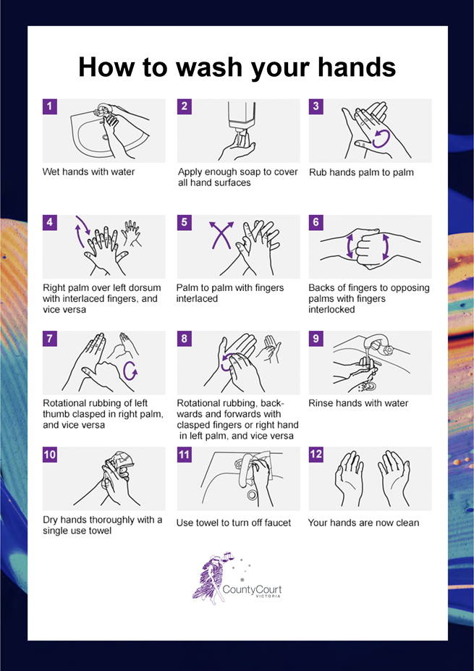

APPENDIX 2: Safe use of hand sanitiser protocol
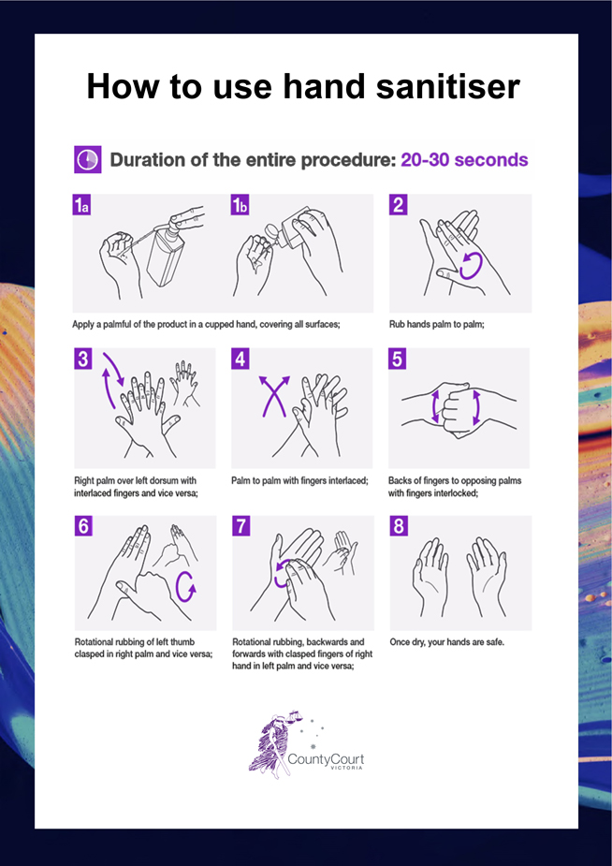

APPENDIX 3: Safe mask use and disposal protocol
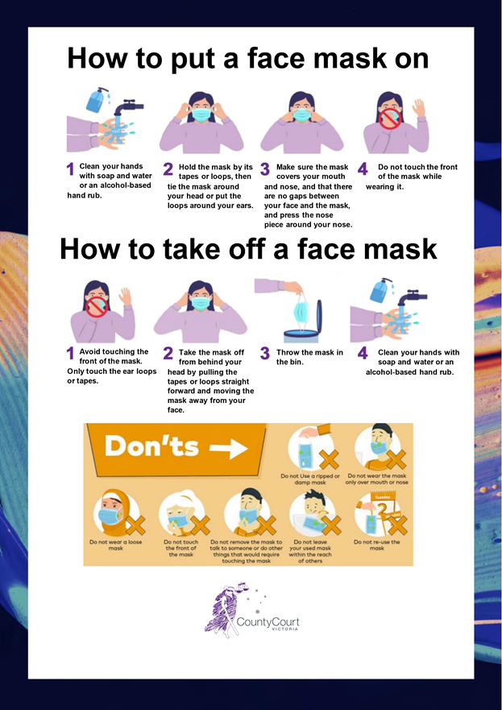
See ‘How to wear a mask’, Australian Government Department of Health: https://www.youtube.com/watch?v=rsBL0yTZNTM

APPENDIX 4: Safe glove use and disposal protocol
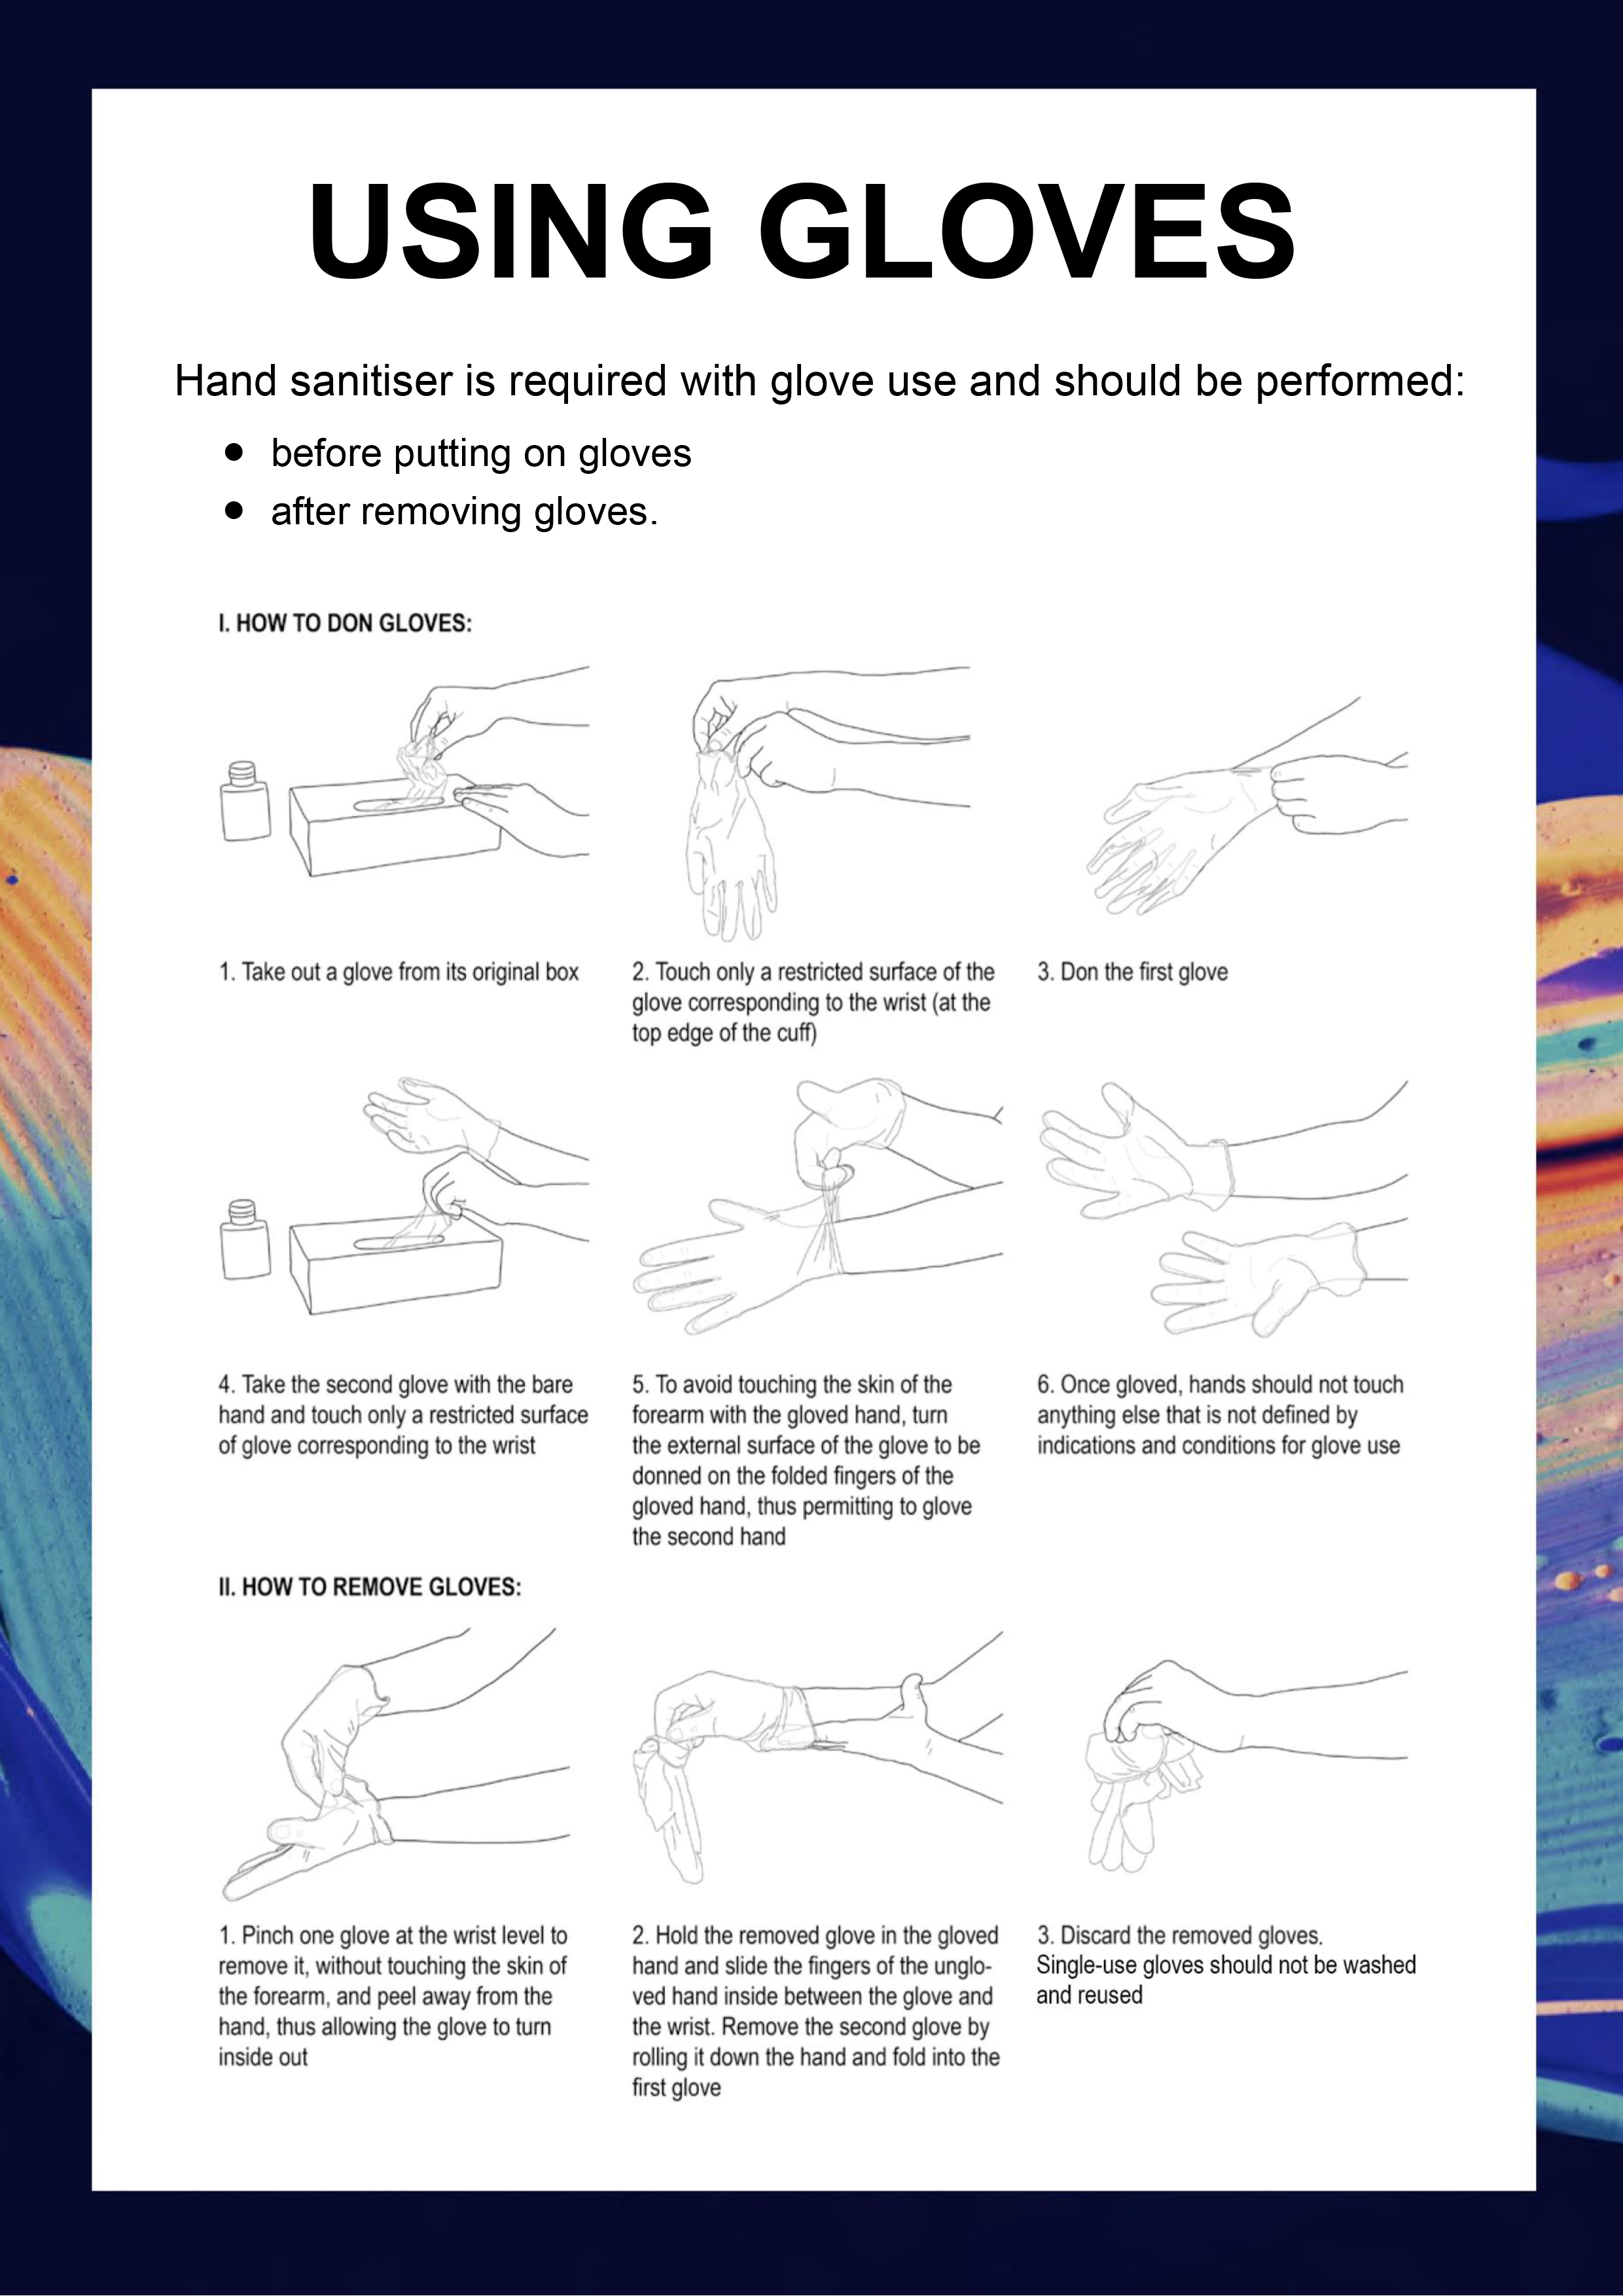
See Ansell’s video ‘How to properly remove single-use gloves’.

APPENDIX 5: Safe use of face shield protocol
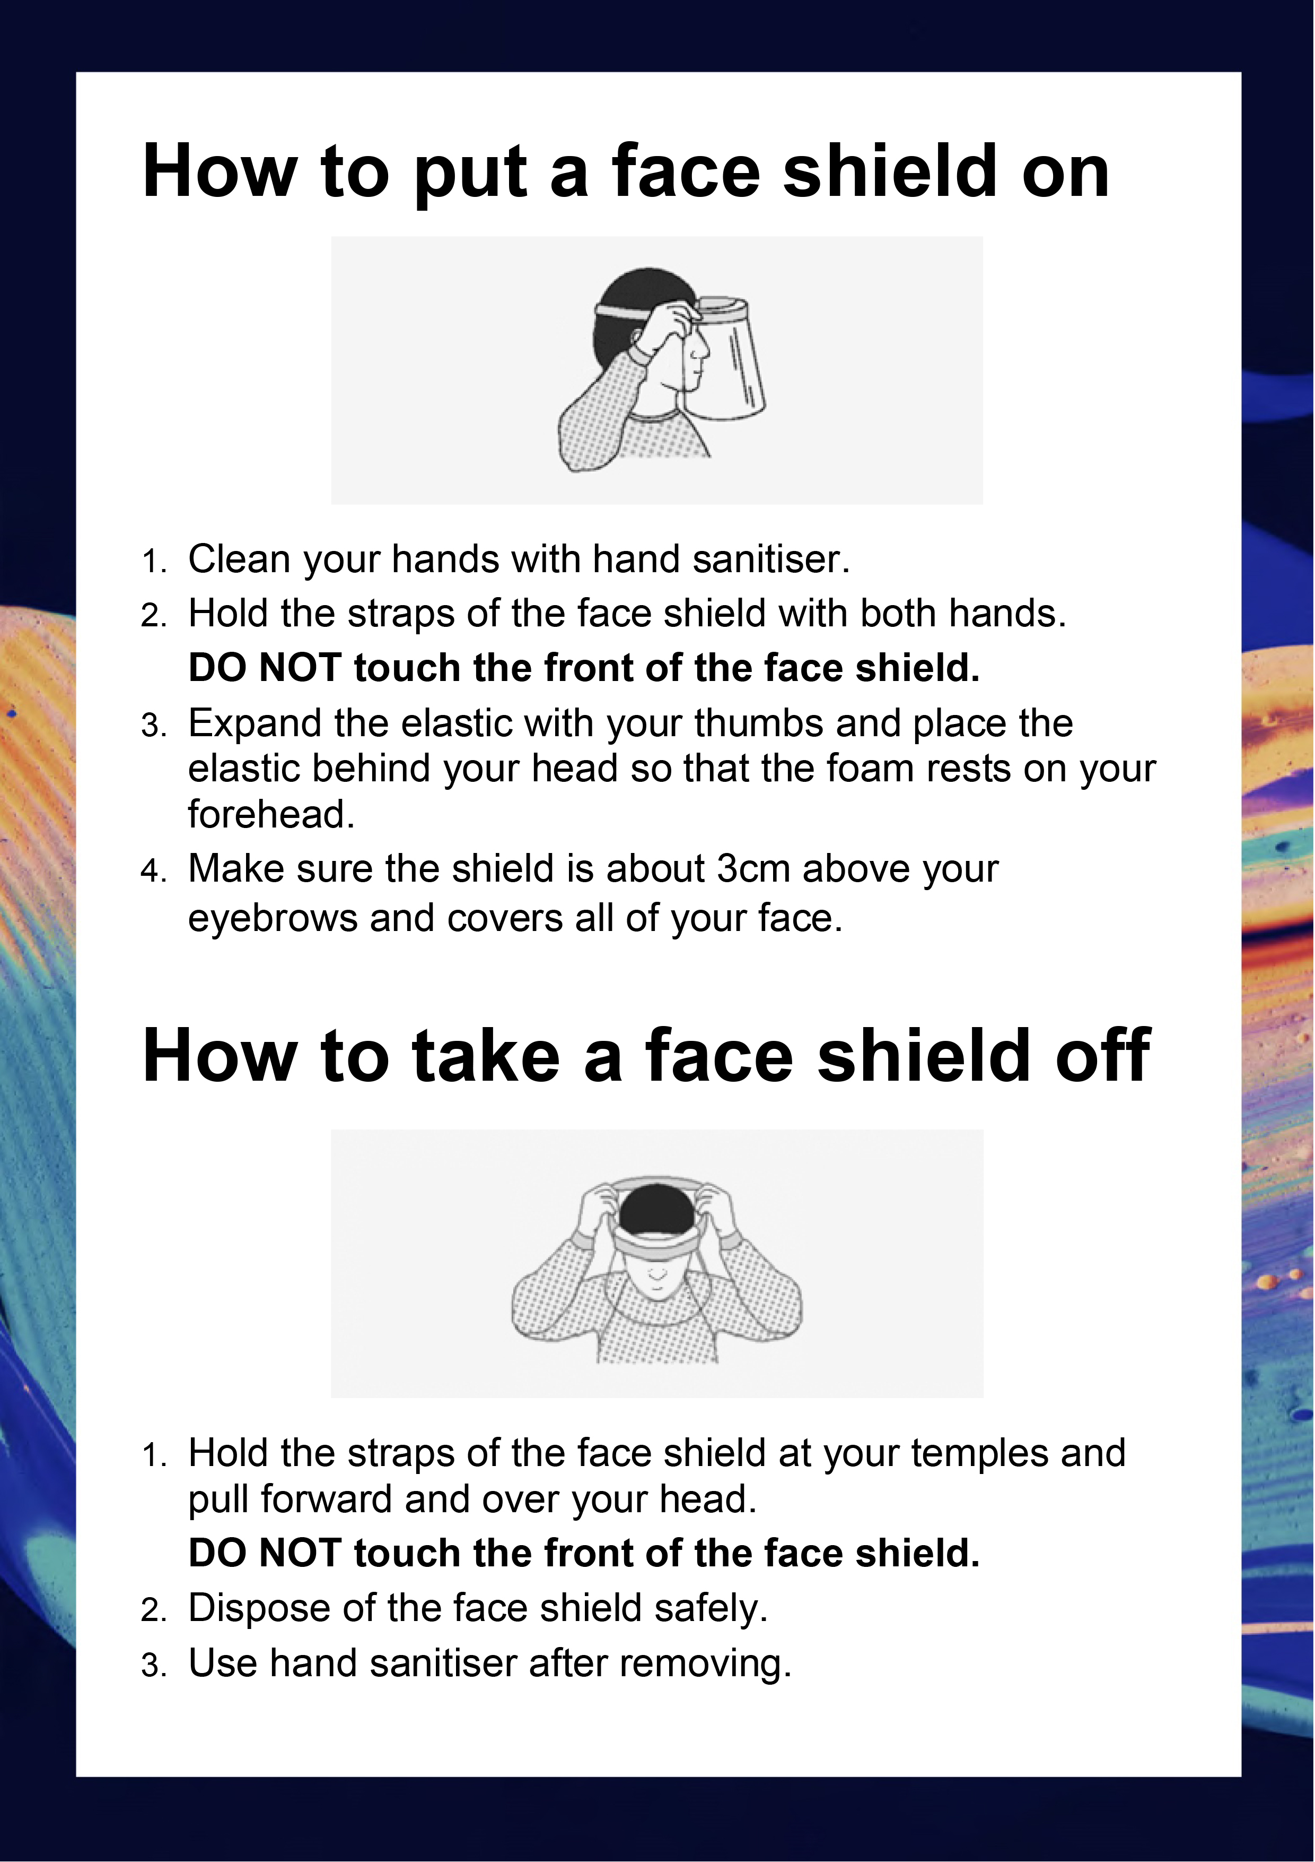

See ss 27(4) – (9) of the Juries Act 2000. NB: These sections are repealed on 26 October 2022.
Note, this protocol is only for use of face shields in the circumstances described in 3.4 regarding in-person witnesses on page 8.

