AUSTRALIA DAY HONOURS 2018
The Bar congratulates the following members of our Bar who received awards:

The Honourable Justice Victoria Jane Bennett AO
The Honourable Howard Tomaz Nathan AM, QC
The Honourable Thomas (Tim) Harrison Smith AM, QC
The Honourable Richard Francis Edmonds AM SC
His Honour Chester Stewart Keon-Cohen AM

We also congratulate:

The Honourable Chief Justice Alan Michael Blow AO, Chief Justice of Tasmania

His Honour Judge Peter Raymond Cole OAM, a Judge of the Federal Circuit Court of Australia

His Honour Robert Krishnan Ashok Kumar OAM, a Reserve Magistrate

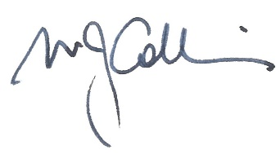
Dr Matthew Collins QC
President
29 January 2017

