COVID-19 response
Circuit criminal jury trials where no physical distancing required – guide for the profession and court users

DOCUMENT CONTROL
Details
Document type | COVID-19 response
Reference | Circuit criminal jury trials where no physical distancing required – guide for the profession and court users
Division | Criminal Division
Authorised by | His Honour Judge Mullaly, Head of the Criminal Division
Notes | This Guide applies where density quotients and physical distancing are not required in the courtroom or spaces used for jury trials.  If density quotients, physical distancing and any other health and safety measures are re-introduced, the County Court will seek expert health advice and may suspend the procedures in this Guide and introduce alternative procedures, where required.

Release history
Version | Date | Author | Summary of changes
1.0 | 4/8/2021 | Laurie Rumbold, Resumption Manager – Criminal Jury Trials (Circuits) and  Scott Smith, Executive Advisor to the CEO | Consolidating previous guides into one document for all circuit court locations. Changes to the content of the guide are consistent, where possible, with the Melbourne criminal jury trials where no physical distancing required – guide for the profession and court users, version 4.
2.0 | 24/11/2021 | Winnie Wang, Criminal Division Senior Administrator | Includes updates to the guidelines if a trial is impacted by COVID-19, and health and safety measures. Also includes measures relating to COVID-19 vaccination for jurors and trial participants. Provides an option for the presiding judge to take a written excuse remotely or in-person in the trial courtroom during empanelment.

CONTENTS
1. Circuit criminal jury trials 5
Application of guide 5
Criminal trial process 5
COVID-safe health and safety overlays principles 5
Mutual obligations to health and safety 5
Related documents and appendices 6
2. Juries Victoria measures 6
COVID-19 information for jurors 6
Applications for excuse or deferral 6
Juries Commissioner’s power to exempt 7
Jury panel 7
3. General information 7
Jury trial vaccination protocol 7
Masks 8
Mask setting 1 – mask-wearing by all trial participants 8
Mask setting 2 – mask-wearing by non-speaking participants 9
Mask setting 3 – mask-wearing not required for trial participants save for limited circumstances (during empanelment) 10
Mask setting 4 – mask wearing not required for trial participants 10
Court-provided disposable masks 11
Disposable gloves 11
Cleaning 12
Juror daily health screening questions 12
QR codes 12
Expedited testing protocol 12
4. Pre-trial matters 13
5. Jury empanelment 14
6. The jury trial in court 22
7. Guidelines if a trial is impacted by COVID-19 28
(a) Trial participant associated with tested person 28
(b) Trial participant tested (suspected case guide) 30
(c) Trial participant tests positive (Positive test guide) 36
APPENDIX 1: Hand washing protocol 39
APPENDIX 2: Safe use of hand sanitiser protocol 40
APPENDIX 3: Safe mask use and disposal protocol 41
APPENDIX 4: Safe glove use and disposal protocol 42
APPENDIX 5: Safe use of face shield protocol 43

Circuit criminal jury trials

Application of guide
  - This Guide applies where there are no density quotient or physical distancing requirements in courtrooms or spaces used for jury trials.
  - If density quotients, physical distancing and any other health and safety measures are re-introduced, the County Court will seek expert health advice and may suspend the procedures in this Guide and introduce alternative procedures, where required.

Criminal trial process
  - Consistent with the Court’s exemption from density quotients and physical distancing for jury trials, the pre-COVID criminal jury trial process will be adopted in so far as possible, but with the necessary modification and COVID-safe overlays outlined in this Guide.
  - Necessary modifications include:
    - the empanelment process will be conducted semi-remotely, using videolinks between the jury pool room and trial courtroom
    - the taking of excuses (if verbal – at discretion of the trial judge)
    - the juror parade will be conducted in-person in the trial courtroom.

COVID-safe health and safety overlays principles
  - The COVID-safe health and safety measures and overlays that remain are intended to comply with the Court’s duty under the Occupational Health and Safety Act 2004 (Vic) to ensure, so far as is reasonably practicable, the health and safety of judicial officers, staff, jurors and court users by:
    - eliminating risks to health and safety so far as is reasonably practicable
    - where it is not reasonably practicable to eliminate risks to health and safety, to reduce those risks so far as is reasonably practicable.
  - The measures outlined in this Guide are specific to jury trials.

Mutual obligations to health and safety
  - All participants in the jury trial will be apprised of, and where required appropriately reminded of, the mutual obligations of all participants to the health and safety of one another.
  - For example:
    - jurors will be instructed that they have a responsibility to stay at home if they are unwell and not place the health and safety of judicial officers, court staff and other court users at risk.
    - all trial participants, including judges, court staff, jurors, counsel, practitioners, witnesses and any other persons permitted in the courtroom are not to attend the Court if they:
- feel unwell, or have any signs or symptoms of COVID-19
- are awaiting test results for COVID-19
- are required, or anyone they live with is required, by public health authorities to take a COVID-19 test OR to stay at home in quarantine or isolation.
  - Legal practitioners, on behalf of each party, must advise the Court if they are aware any trial participant feels unwell or has signs or symptoms of COVID-19, are awaiting test results for COVID-19 or are required, or anyone they live with is required, by public health authorities to take a COVID-19 test OR to stay at home in quarantine or isolation.
  - Parties should contact the chambers of the presiding judge if a trial participant is unable to attend due to any of the reason(s) outlined in paragraph 1.8. The judge will then decide the future conduct of the matter which may include alternative remote appearance arrangements or an adjournment.

Related documents and appendices
  - This guide should be read in conjunction with the following documents:
    - Hand washing protocol (see Appendix 1)
    - Safe use of hand sanitiser (see Appendix 2)
    - Safe mask use and disposal protocol (see Appendix 3)
    - Safe glove use and disposal protocol (see Appendix 4)
    - Safe face shield use and disposal protocol (see Appendix 5)
    - Court Services Victoria’s COVID Safe Plan
    - Jury trial vaccination protocol
    - Personal protective equipment (PPE), movement and testing protocol.

Juries Victoria measures

COVID-19 information for jurors
  - Jurors will be asked to check the Juries Victoria website for information about the precautionary measures and guidelines for their attendance.
  - The Juries Victoria website includes advice that jurors are not to attend the Court, and must call Juries Victoria, if they:
    - feel unwell, or have any symptoms of coronavirus (COVID-19)
    - are awaiting test results for COVID-19
    - are required, or anyone they live with is required, by public health authorities to take a COVID-19 test OR to stay at home in quarantine or isolation.

Applications for excuse or deferral
  - In addition to the more commonplace reasons for deferral (such as pre-booked leave, small business ownership, etc.) Juries Victoria will give greater consideration to excusing or deferring persons who may be particularly vulnerable to the consequences of COVID-19, or who, for example, would have difficulty complying with the requirement to wear a mask, or have issues with providing consent or undergoing a COVID-19 test if required.

Juries Commissioner’s power to exempt
  - The Juries Commissioner may exempt a person or class of persons from being summonsed for jury service if, in the Commissioner’s opinion, there is good cause to do so based on health, safety or welfare concerns relating to the person, that class of persons or the community.
  - Having formed the opinion there is a good cause to do so based on health, safety and welfare concerns relating to the class of persons and the community, pursuant to s 27(4) of the Juries Act 2000, the Juries Commissioner has exempted the following class of persons from being summonsed for the period 26 November 2021 to 11 February 2022:
    - Persons who have not been fully vaccinated against COVID-19 excluding persons who provide an Australian Immunisation Register immunisation medical exemption form that is completed and signed by the person’s medical practitioner and states that the person is unable to receive a does or a further dose of a COVID-19 vaccine due to a medical contraindication or an acute medical illness; and
    - Persons who fail or refuse, prior to the date they are required to attend for jury service or immediately upon attending for jury service, to provide either satisfactory evidence of being fully vaccinated or an Australian Immunisation Reiser immunisation medical exemption form that is completed and signed by the person’s medical practitioner and states that the person is unable to receive a dose or further dose of a COVID-19 vaccine due to a medical contraindication or an acute medical illness.
  - If a person, or class of persons, has a medical exemption from vaccination, the Juries Commissioner may provide that person with an opportunity to serve, defer their service or be excused or exempted from jury service.

Jury panel
  - The empanelment process will be conducted using videolinks between the trial courtroom and the jury pool room. The size of the jury pool will vary at each circuit court location.
  - A maximum of one jury empanelment will occur per day unless arrangements have been made with the onsite Jury Coordinator and Senior Registrar for the accommodation of two empanelments. Members of a panel who are not excused or not selected for a jury will be discharged from service. Jurors will not be required to participate in more than one empanelment on a given day unless the arrangements above require that this is the case.

General information

Jury trial vaccination protocol
  - As an additional measure of safety, the Court has implemented a Jury trial vaccination protocol and Personal protective equipment (PPE), movement and testing protocol which will apply to all criminal jury trials unless otherwise advised by the Court.
  - The Court’s approach to risk assessment takes account of the particular operational requirements of the County Court, including the volume of jury trials which will be conducted at the Court on a daily basis and the corresponding number of people in attendance.
  - Against that background, the Court is obliged to take all practicable steps to reduce the COVID-19 health risks to all participants in the jury trial environment and to reduce the prospect of disruption. This must be balanced against the need to ensure that the interests of justice are served.
  - One practical and effective way to do this is to keep the presence and mixing of unvaccinated trial participants in the courtroom trial environment to the absolute minimum, especially with respect to those persons who play a central, ongoing and speaking role in the trial.
  - The Jury trial vaccination protocol and Personal protective equipment (PPE), movement and testing protocol outline the Court’s approach to jury trials where there may be vaccinated and unvaccinated trial participants.
  - All trial participants including legal practitioners, should refer to the Court’s Jury trial vaccination protocol and Personal protective equipment (PPE), movement and testing protocol for further information.

Masks
  - The Court’s requirement for trial participants to wear masks is described by the following settings:
    - Mask setting 1 – mask-wearing by all trial participants is required
    - Mask setting 2 – mask-wearing by non-speaking participants is required and opening and closing addresses made from the end of the bar table
    - Mask setting 3 – mask-wearing is not required for trial participants save for limited circumstances (during empanelment only)
    - Mask setting 4 – mask-wearing is not required for trial participants, but may be worn voluntarily (save for circumstances where removal is required)
  - These requirements are subject to any additional requirements provided for by the Jury trial vaccination protocol and Personal protective equipment (PPE), movement and testing protocol.
  - The appropriate setting will be determined by health advice, and the Court will publish advice, on an ongoing basis, as to the setting that is currently in effect.
  - The chambers of the presiding judge will also advise parties of the setting prior to the commencement of a trial, and during a trial should the setting change.

Mask setting 1 – mask-wearing by all trial participants
  - Where health advice requires mask-wearing by all participants, all trial participants (judges, court staff, jurors, counsel, practitioners, witnesses and any other persons permitted in the courtroom) will be required to wear masks – including when speaking – save for in the following limited circumstances:
    - the accused will be required remove their mask when pleading during the arraignment
    - a juror may be required to briefly move their mask to one side, while holding the straps, during the callover and answering ‘Present’ or ‘Excuse’
    - a juror may be required to remove their mask when addressing the Court during the provision of any verbal excuse, or when addressing to the Court regarding a written excuse
    - a juror will be required to remove their mask during the empanelment of the jury and the parade
    - an in-person witness will be required to remove their mask when being sworn in and for a short period thereafter – as determined by the judge – for the purposes of identification
    - an in-person witness may be required to remove their mask for short periods – as determined by the presiding judge – to facilitate the assessment of the witness’ credibility, during which period a face shield will be worn (see Appendix 5).
  - Any witness appearing remotely is not required to wear a mask while giving evidence.
  - Court staff will not be required to remove their mask at any time, save for the brief period required for identification to the jury panel during empanelment (if this is the preference of the judge). Court staff will continue to wear a mask immediately thereafter.
  - Courtroom microphones will be set to provide a measure of amplification (not just recording) to reduce the need of any person speaking to project their voice.
  - Counsel and instructing solicitors will be requested to wear a disposable mask provided by the Court (using the Safe mask use and disposal protocol in Appendix 3) to allow for any removal and disposal during the empanelment process when trial participants are asked to identify themselves for the benefit of the jury panel.
  - While masks may be removed pursuant to the exemptions above while in court, court users must continue to wear masks when moving throughout the court facility.
  - During orientation, jurors will be provided information (including an instructional video) on the correct process for changing masks as required throughout the empanelment process and the trial.
  - If a person removes a mask, they must dispose of it in the bin provided and use hand sanitiser before selecting and fitting a new mask.
  - The Court will continue to monitor the circumstances and will seek ongoing health advice to determine if this setting is appropriate.

Mask setting 2 – mask-wearing by non-speaking participants
  - Where health advice permits speaking participants to remove their masks, masks will be worn by all trial participants, save for in the following circumstances:
    - judicial officers and those speaking or addressing the Court, including counsel and witnesses, may remove masks
    - the accused will be required remove their mask when pleading during the arraignment
    - a juror may be required to briefly move their mask to one side, while holding the straps, during the callover and answering ‘Present’ or ‘Excuse’
    - a juror may be required to remove their mask when addressing the court during the provision of any verbal excuse, or when addressing to the court regarding a written excuse
    - a juror will be required to remove their mask during the empanelment of the jury and parade
    - any witness appearing remotely, or in-person is not required to wear a mask while giving evidence (after giving evidence in-person, a witness must use hand sanitiser before selecting and fitting a new mask).
  - As an additional measure of comfort to the jury, counsel will be required to conduct any address to the jury from the end of the Bar table furthest from the jury. The instructing solicitor may also move position to sit near counsel as they address the jury.
  - Counsel and instructing solicitors should move towards the centre of the Bar table (if required) when the opposing counsel is addressing the jury.
  - Those addressing the Court may choose to continue to wear a mask so long as they can be clearly heard and understood, at the discretion of the judge.
  - Any witness appearing remotely is not required to wear a mask while giving evidence.
  - Court staff will not be required to remove their mask at any time, save for the brief period required for identification to the jury panel during empanelment (if this is the preference of the judge). Court staff will continue to wear a mask immediately thereafter.
  - Courtroom microphones will be set to provide a measure of amplification (not just recording) to reduce the need of any person speaking to project their voice.
  - Counsel and instructing solicitors will be requested to wear a disposable mask provided by the Court (using the Safe mask use and disposal protocol in Appendix 3) to allow for any removal and disposal during the empanelment process when trial participants are asked to identify themselves for the benefit of the jury panel.
  - While masks may be removed pursuant to the exemptions set out in paragraph 3.20 while in court, court users must continue to wear masks when moving throughout the court facility.
  - During orientation, jurors will be provided information (including an instructional video) on the correct process for changing masks as required throughout the empanelment process and the trial.
  - If a person removes a mask, they must dispose of it in the bin provided and use hand sanitiser before selecting and fitting a new mask.
  - The Court will continue to monitor the circumstances and will seek ongoing health advice to determine if this setting is appropriate.

Mask setting 3 – mask-wearing not required for trial participants save for limited circumstances (during empanelment)
  - Where health advice permits, the wearing of masks by all trial participants (including the judge, court staff, accused, counsel, instructing solicitors, witnesses, jurors) will be voluntary, and they will not be required to wear a mask (unless they wish to), save for during empanelment as follows:
    - during in-court empanelment, jurors will be required to wear masks while in the jury pool, in any public areas and while in the trial courtroom for empanelment (save for the points at which they are required to remove their mask – see paragraph 3.13 (c) – (e)). Jurors may remove their mask during the first adjournment after empanelment
    - trial participants will be required to wear a mask when moving in any public areas.
  - Following empanelment, empanelled jurors are not required to wear a mask unless they wish to.
  - Trial participants are required to carry a mask with them at all times.
  - The Court will continue to monitor the circumstances and will seek ongoing health advice to determine if this setting is appropriate.

Mask setting 4 – mask wearing not required for trial participants
  - During mask setting 4, masks are not required to be worn by all trial participants.
  - Trial participants may wear a mask if they wish, subject to the following:
    - those addressing the Court may choose to continue to wear a mask so long as they can be clearly heard and understood, at the discretion of the judge
    - the accused will be required to remove a mask when pleading during the arraignment
    - a juror will be required to briefly move a mask to one side, while holding the straps, during any callover and answering ‘present’ or ‘excuse’ during empanelment
    - a juror will be required to remove a mask when addressing the Court during the provision of any verbal excuse, or when addressing to the Court regarding a written excuse
    - a juror will be required to remove a mask during the empanelment of the jury.
  - If a person requires a new mask, they must use hand sanitiser before selecting and fitting a new mask.
  - The Court will continue to monitor the circumstances and will seek ongoing health advice to determine if this setting is appropriate.

Court-provided disposable masks
  - Disposable masks will be available to all court users and those attending for jury service and participating in a trial.
  - Jurors or trial participants arriving at the Court wearing their own mask (for example, a non-disposable mask) will be provided with a disposable mask by Juries Victoria staff, and asked to wear a disposable mask, to allow for ease of removal, disposal and for fresh mask(s) to be used throughout the empanelment process and trial (if required). Jurors will be notified of this requirement by Juries Victoria staff.
  - Disposable masks will be available for jurors:
    - at entrance points before security screening
    - in the jury pool room
    - in the trial courtroom (for use during the empanelment process)
    - in the jury deliberation room.
  - Disposal bins and hand sanitiser will also be provided next to all masks distribution points to allow for safe mask use in accordance with the Safe mask use and disposal protocol (see Appendix 3).
  - In addition to the requirement that a new mask be worn whenever one is removed, on the advice that masks are to be refreshed every four hours, jurors and all court users will be provided with a fresh mask after any mid-sitting break in the sitting the juror wishes to wear a mask (see Appendix 3).
  - Supplies of additional masks and appropriate bins for safe mask disposal will be provided in the jury pool room, trial courtroom and the jury room.

Disposable gloves
  - Disposable gloves will be available to judges, court staff, legal representatives and jurors participating in a trial. The gloves will be available:
    - on the judge’s bench (for the judge)
    - on the judicial staff bench (for judicial staff and jurors)
    - on the Bar table (for legal representatives)
    - in the jury deliberation room (for jurors).
  - Hand sanitiser will also be provided next to gloves to allow for safe glove use and disposal in accordance with the Safe glove use and disposal protocol (see Appendix 4).

Cleaning
  - The Court has established an additional cleaning regime for the jury pool room, jury deliberation room, trial courtroom, and bathroom spaces with a focus on high touch points in areas used by multiple people. For example, high touch points in the witness box will be cleaned between witnesses.

Juror daily health screening questions
  - Upon entry to the Court building each day, members of the jury panel will be asked by a court security officer (and empanelled jurors will be asked by a court staff member) the following questions:
    - do you feel unwell, or have any symptoms of coronavirus (COVID-19)?
    - are you awaiting test results for COVID-19?
    - are you or anyone you live with required by public health authorities to take a COVID-19 test OR to stay at home in quarantine or isolation?

QR codes
  - In line with the Victorian Government health directions and record-keeping obligations, all trial participants (including jurors, counsel, bailed accused, solicitors, and witnesses) must check in using the QR code digital system each time they enter the Court building. This includes if a trial participant leaves the building and returns on the same day for example, during lunchtime breaks.
  - If a trial participant does not have a mobile phone or other electronic device which enables them to electronically check in using the QR code, trial participants will check in manually using a sign in sheet.
  - Judges and court staff are only required to check in once a day when first entering the building.

Expedited testing protocol
  - The Court and Court Services Victoria have developed an expedited testing protocol which will facilitate the testing of any trial participant for COVID-19, and the receipt of results within 24 hours.
  - It is anticipated that a trial would be permitted to continue after a maximum adjournment of one day in order to facilitate the testing and receipt of the results.
  - Jurors will be advised in advance of attendance at court that they will be asked to consent to a testing protocol if selected as a juror and will be reminded of this during their orientation, although completing the consent forms (and ultimately any testing) is voluntary.
  - Parties will be provided in advance of the trial with consent forms to complete (if they wish) and send to the chambers of the presiding judge for safe retention, in the event that expedited testing of counsel, instructing solicitors or witnesses is required.

Pre-trial matters
  - It is suggested that, in addition to the usual matters, counsel should assist the Court by addressing the following matters, if not already raised with the judge’s chambers:
    - confirming witness arrangements particularly with regard to those witnesses that will appear remotely using videolinks
    - whether an interpreter is required for the accused or any witness
    - whether a view is required
    - confirming with the Court the anticipated desire of family or supports to attend the trial and that specific arrangements for limited in-court or remote viewing will need to be made.

Jury empanelment
  - Until further notice, extended jury boxes will remain in those circuit courtrooms which had their jury boxes extended to facilitate the prior requirement of 1.5m physical distancing.
  - Due to the removal of courtroom public seating, jury empanelments will be conducted semi-remotely via videolink between the jury pool room and the trial courtroom.
Jury empanelment procedure
  - The table below outlines modified procedures for a semi-remote jury empanelment. The jury panel will remain in the jury pool room while the associate conducts the jury panel callover via videolink. Jurors are transferred between the jury pool room and trial courtroom for the taking of verbal excuses and for the juror parade when empanelling the jury.
Event | Procedure
COVID testing consent forms | Juries Victoria staff distribute consent forms to members of the jury panel when checking them into the pool room.  Individual pens will be provided.  The consent forms will be collected by Juries Victoria staff (Safe glove use and disposal protocol used (see Appendix 4)) before the commencement of the empanelment process.
Preparation of the jury pool room | The jurors’ panel number will be placed under their seat in the jury pool room.  Individual chairs in the jury pool room are numbered in sequential order.  If required, list of witnesses/parties placed on jurors’ seats.
Panel arrives at court | As members of the panel arrive at Court, and register with Juries Victoria staff, they will be directed to answer the following health screening questions:  - do you feel unwell, or have any symptoms of coronavirus (COVID-19)?  - are you awaiting test results for COVID-19?  - are you or anyone you live with required by public health authorities to take a COVID-19 test OR to stay at home in quarantine or isolation?  If the panel member answers ‘yes’ to any of the questions, they will not enter the pool room, and will be directed to isolate and/or seek medical assistance as required.  Panel members will also be asked to provide proof of their vaccination status or medical exemption.  If a panel member is unable to provide proof of their vaccination status or medical exemption, they will either be exempted by Juries Victoria or deferred to a different date where they can provide proof of their vaccination status or medical exemption.  If the panel members answer ‘no’ to each health screening question, and provides proof of their vaccination status or medical exemption, they will be directed by Juries Victoria staff to sit in their assigned seat in the jury pool room.
Jurors go to jury pool room and take numbered seat | Under mask settings 1, 2 and 3, masks are required to be worn by jurors when seated in the jury pool room.  Under mask setting 4, masks are not required to be worn, but jurors may wear a mask if they wish.  Jurors wearing a non-disposable mask, or their own personal mask, will be provided with and asked to wear a disposable mask, to allow for ease of removal, disposal and for fresh mask(s) to be used throughout the empanelment process and trial if selected as a juror.  The number of jurors assembled to provide panels will vary depending on the circuit court location.  Signs, floor stickers guide way to pool room.  Signs outside and inside pool room with information on hygiene, sanitiser availability, coughing etiquette, mask use and disposal and glove use and disposal.  The juror is provided a slip of paper indicating their panel number. Safe glove use and disposal protocol (see Appendix 4) used.  Jurors will be seated in their numbered chairs.  Jurors asked to use hand sanitiser and select at least two additional masks to carry with them to use during the empanelment process.
If required, jurors check list of trial witnesses and parties | If list is required, tipstaff/associate place lists on jury panel seats in the jury pool room before empanelment. Safe glove use and disposal protocol (see Appendix 4) followed.  Lists remain at seats and collected with gloves (and disposed of) after remaining jury panel has been discharged at conclusion of empanelment. Safe glove use and disposal protocol (see Appendix 4) followed.
Jurors in pool room given induction/orientation | Juries Victoria staff will conduct orientation in the jury pool room. Jurors given briefing on mask wearing (if required), hygiene, COVID safety measures, limiting exposure outside the court, bathroom location, testing protocol and requirement to complete testing consent forms. All jurors will complete consent forms as a component of the orientation.  Jurors asked to use only assigned seat and not wander around the room.  Juries Victoria staff will advise tipstaff when orientation is complete.  Tipstaff will attend the jury pool room to give an overview of the process to the panel, describing the:  - arraignment  - callover  - movement to the courtroom for the taking of excuses – and provision of written excuses if required  - empanelment of the jury and process of movement to the courtroom for the empanelment  - challenges  After providing this overview, the tipstaff will collect the ballot cards from the Juries Victoria staff member. Safe glove use and disposal protocol (see Appendix 4) followed.  Tipstaff returns to the trial courtroom.  Jury panel members remain seated in the jury pool room.
Judge opens court | Matter is called on in trial courtroom in the absence of the jury panel.  Judge, associate, tipstaff, counsel, instructing solicitors, accused and Corrections or Victoria Police officer present in the trial courtroom.  Juries Victoria staff member remains in the jury pool room.  Discussion of any outstanding issues and confirmation of witnesses.  Associate or tipstaff advises Juries Victoria officer in the jury pool room that the judge is ready to empanel.
Authorisation and address to jury panel | Judge, associate, tipstaff, counsel, instructing solicitors, accused and Corrections or Victoria Police officer remain in the trial courtroom.  Tipstaff establishes videolink between the jury pool room and the trial courtroom.  Juries Victoria officer will advise tipstaff when all persons are in place.  Tipstaff advises judge/associate court is ready.  Matter is called on for a second time in the presence of the jury panel, who are seated in the jury pool room.  Judge declares the jury pool room an extension of the Court and the associate an authorised officer for the purposes of calling the panel and selecting the jury.
No initial callover | To reduce the overall empanelment time, no initial callover is conducted prior to arraignment.
Directions to jury panel | Judge provides introductory remarks to the jury panel on the process of empanelment, and COVID safety throughout the process.  Judge provides usual information (see s 32 of Juries Act).
Arraignment of accused | Accused remain(s) in the dock while arraigned.  If an accused is wearing a mask, they must remove their mask for the arraignment and dispose of the mask in the bin in front of dock (provided).  Jury panel observe the accused during the arraignment via videolink from the jury pool room.  Associate arraigns the accused from the trial courtroom, remaining at the judicial staff area for this process.  After the accused is/are arraigned, they must use hand sanitiser (provided) and fit a new mask (provided) if required to wear a mask under mask settings 1 and 2, or if they choose to wear a mask under mask setting 3 or 4.  CAMERA  - During the arraignment a portrait (from chest to above the head) close-up view of the accused will be seen by the jury panel in the jury pool room.  - When the judge names court staff (if it is the practice of the judge), counsel and instructors, the camera view will be focused on the centre of the Bar table, allowing court participants to move into view of the camera, in sequence, as they are named.  - If in mask setting 1 or 2 (if a participant is in a non-speaking role), each participant, including counsel and solicitors, must remove their mask to be seen. They must then dispose of the mask in the bin provided on the floor near the centre of the Bar table, then use hand sanitiser (provided on the Bar table), before picking up and fitting a new mask (provided on the Bar table).  - The camera view will then need to be returned to the judge for the call over.  Judge advises jury panel that, when their number is called, potential jurors should state ‘Present’ or if seeking to be excused, state ‘Excuse’ during the callover.  Judge reinforces that any panel members who are in vulnerable groups, or who have any other concerns should seek to be excused.  Judge directs the associate to call through the jury panel.
Call over of jury panel | Videolink is continued  Associate reminds the jury pool that the numbers that will be called out are their panel numbers, which have been highlighted.  Associate instructs the jury pool that when their panel number is called, they should stand at their seat and answer with ‘Present’ or ‘Excuse’.  Associate calls over the panel.  If a juror is wearing a mask and where required by the judge, jurors will be requested to move their mask to one side, or briefly take it off, using the mask straps, while answering the callover.  CAMERA  - Juries Victoria staff will pan the jury pool room camera across jury pool as the jury is called over, using pre-set views.  - The jury pool room view is of the judge.  Associate will separate cards of jury panel members who seek to be excused for the judge.  Associate queries if there are any jurors present whose panel number has not been called.  Associate advises judge that all jurors are present.
Taking of excuses | Videolink is continued.  Judge advises panel members that the Court will now hear excuses.  Unless otherwise directed, all panel members seeking to be excused are required to attend the trial courtroom, in turn, when their number is called.  Associate reads the number of the panel member seeking to be excused.  The tipstaff or associate will meet the jury panel member at a designated spot between the jury pool room and the trial courtroom (this varies between locations, but the jury panel member is supervised at all times within public spaces during this process) before escorting the panel member into the courtroom and providing direction to the panel member on where to stand when they arrive.  Any juror seeking to be excused who is wearing a mask must remove their mask and dispose of it in the bin (provided).  Judge advises juror that sensitive excuse may be provided in writing, if panel member indicates this is required.  If verbal:  - If judge requires juror to give oath for purpose of seeking excuse, religious texts not used.  - Judge hears and determines excuse.  If written (taken in the courtroom):  - Panel member is asked to move to the witness box where the tipstaff/associate will provide the panel member with a clipboard, pen and paper to write his or her excuse. Hand sanitiser will be available by the witness box. The panel member will write his or her excuse on the paper provided, fold and hand to the tipstaff/associate.  - Tipstaff hands excuse to the judge following Safe glove use and disposal protocol (see Appendix 4);  - Written excuse is received by judge and then considered.  - Used clipboard and pen to be placed to one side for cleaning.  - Following the judge’s determination, the tipstaff or associate will escort the juror back to the jury pool room and the Juries Victoria staff member direct they return to their assigned seat.  - All panel members return to their assigned seat in the jury pool room – whether excused or otherwise.  If written (taken remotely in the jury pool room):  - Tipstaff attends jury pool room.  - Panel member provided with a clipboard, pen and paper to write his or her excuse in view of the camera in the jury pool room. Safe glove use and disposal protocol followed when providing clipboard, pen and paper to panel member.  - Juries Victoria staff will pan the jury pool room camera across to panel member, using pre-set views.  - Panel member writes his or her excuse and provides to tipstaff.  - Used clipboard and pen to be placed to one side for cleaning.  - Tipstaff conveys written excuse to judge for determination following Save glove use and disposal protocol.  - Judge receives written excuse, considers and determines.  - Depending on the preference of the judge, written excuses can be conveyed to the trial courtroom in a batch or individually after a panel member has completed writing his or her excuse.  If in mask setting 1, 2 or 3, or if the panel member chooses to wear a mask under mask setting 4, the panel member will fit a new mask using one of the additional masks the panel member has carried with them from the jury pool room.  If excused, the associate excludes the panel member’s number from the ballot for empanelment.  If there is more than one juror seeking to be excused, this process is then repeated for all other jurors.
Empanelling the jury | Videolink is continued.  Judge directs associate to empanel a jury.  Associate provides usual advice to the accused on rights to challenge.  Defence counsel asks permission for instructing solicitor to stand/sit beside accused in the dock.  Associate remains at the associate desk.  CAMERA  - The jury panel views the associate as they call each jury number from the associate desk.  - The view in the trial courtroom will be of the jury panel.  Associate uses gloves to ballot jurors or uses hand sanitiser after ballot.  Associate advises the jury panel that, as their number is called, they should stand and walk to the front of the jury pool room. Tipstaff or associate will meet panel member in designated spot before escorting them to the trial courtroom for the parade.  Juries Victoria staff member instructs the panel to remain in their assigned seats.  If a juror is wearing a mask, they must remove the mask and dispose of it in the bin provided in the trial courtroom, prior to the parade.  Associate then instructs the panel member to pass in front of the dock in a manner as directed by the judge before making their way to the furthest seat in the jury box.  If no challenge/request to stand aside is made, the juror will be seated in the box.  If selected, and if in mask setting 1, 2 or 3 or if a juror chooses to wear a mask under mask setting 4, juror to fit a new mask with one of the additional masks they brought with them from the jury pool room, upon being seated in the jury box.  Juries Victoria officer then returns to the jury pool room to collect and escort the next balloted juror. Associate must wait for the Juries Victoria officer to return to the jury pool room before balloting the next potential juror.  If a challenge/request to stand aside is made, the tipstaff will escort the panel member to the jury pool room or designated spot close to the door of the pool room, where they are instructed to return to their assigned seat.  If in mask setting 1, 2 or 3 or if a juror chooses to wear a mask under mask setting 4 the juror will fit a new mask with one of the additional masks they brought with them from the jury pool room, before exiting the trial courtroom.  The tipstaff will then wait at the door of the jury pool room/designated spot for the next balloted panel member to be directed to them.  Once it is clear the challenged/stood aside panel member has returned to the jury pool room, the associate will ballot the next panel member who will be escorted to the trial courtroom by the tipstaff.  This process is repeated until a jury of 12 has been empanelled.
Challenge for cause | An accused may challenge a potential juror for cause during empanelment.  If a challenge for cause is made, the judge will instruct the potential juror to leave the trial courtroom. The juror will be escorted outside of the courtroom by the tipstaff/associate. Videolink to jury pool room is temporarily switched off to determine the matter (unless otherwise directed by judge).  Judge hears and determines challenge for cause in absence of the potential juror and videolink to jury pool room (unless otherwise directed by judge).  Judge instructs associate to advise tipstaff/co-associate and potential juror to return to the trial courtroom.  Videolink to jury pool room re-established.  Judge advises the juror if they have been selected, or if they have been successfully challenged, and instructs the juror to either take their place in the jury box (if selected) or return to the jury pool room (escorted by tipstaff/associate) and directed to their assigned seat.
Empanelled jurors sworn in as jury | Videolink is continued.  Once 12 jurors are empanelled, the judge directs remaining jury panel members to remain seated in their assigned seats in the jury pool room until discharged.  Jurors asked to stand and give an oath or make an affirmation. Under mask setting 1, 2 or 3, or if a juror chooses to wear a mask under mask setting 4, jurors to continue wearing a mask when giving an oath or making an affirmation provided they can be clearly heard and understood.  Judge provides advice that, due to COVID-safe measures, religious text will not be provided for those wishing to swear an oath, but it will still have full force and effect.  Jurors sworn in.
Remaining panel members discharged | Videolink continued.  Associate advises the prosecutor that the accused is in the charge of the jury.  Judge discharges the remainder of the panel using the videolink.  Videolink is terminated.
Overnight cleaning of jury pool room | Entire jury pool room cleaned and disinfected overnight.

The jury trial in court
  - The following table outlines modified procedures to support the health and safety of judges, staff, jurors and court users from commencement of the trial to verdict.
  - The procedures are described on the basis that, after the empanelment process is completed, and the judge’s initial directions given, the judge should ordinarily adjourn for that day.
  - On the next day of the trial, the jurors will choose their foreperson prior to entering the trial courtroom for that day – allowing any necessary re-seating to take place in a safe manner (given the overnight cleaning that will have taken place).
  - Staggered start and finish times may be adopted where necessary to accord with local Magistrates’ Court of Victoria listings. For example, where the Magistrates’ Court conduct a regular list on a specified day, which ordinarily requires a large number of court users attending in person, a delayed start time may be adopted to minimise traffic and congestion.
Event | Procedure
First adjournment after jury sworn in | The Court is adjourned to allow jurors to visit and familiarise themselves with jury room (under instruction of tipstaff) and have bathroom break.  Relevant instructions based on current mask setting and associated requirements to be provided to jurors at this time.
Jury enter jury deliberation room | Tipstaff/jury keeper escorts jury to the jury room.  Numbered stickers or labels identify which seats can be used. Each juror should use the same seat each day.  Jury asked to choose seat and ensure use of that seat throughout the entire trial.  Room cleaned and disinfected overnight and high touch points disinfected twice daily.  Disposable cups and cutlery in kitchenette.  Sanitising wipes and sanitiser available at kitchenette and in bathroom.  Signs inside jury room with information on hygiene, sanitiser availability, coughing etiquette etc.  Jury given briefing on hygiene, COVID-safety measures, limiting exposure outside the court and mask wearing (if required).  Jury informed of where their private bathroom, kitchenette and storage (pigeonhole) are and protocol for use.  Disposal bins, hand sanitiser and replacement masks in deliberation room in prominent locations.  Safe glove use and disposal protocol displayed.  Safe mask use and disposal protocol displayed.  Each juror supplied with a small bottle of hand sanitiser they can keep on them.  Each juror supplied with individual pens, whiteboard markers and paper.
Initial directions to the jury following adjournment | Court resumes after adjournment.  Jurors provided usual initial directions, in addition, provided directions on COVID-safety including:  - Importance of maintaining the same seat in the jury room and in the trial courtroom when they first return after choosing a foreperson.  - Importance of cough etiquette and hand hygiene.  - Importance of reporting if they experience symptoms at any time and to contact the court before coming in if symptomatic.  - Importance of minimising their risk of exposure outside of court.  - Importance of electronically signing in using the QR code digital system each time they enter the building, including if they leave the building and re-enter throughout the day for example, during lunchtime breaks.
Directions for choosing foreperson | When considered appropriate by the presiding judge, the jury is asked to choose a foreperson.  This should occur at a time so as to allow for overnight cleaning, before re-seating of the jury (i.e., the jury may be asked at the conclusion of one day to appoint a foreperson before commencing the following day).
Jury takes assigned seats for trial after choosing foreperson | Jury seats in court to be numbered on floor (not visible outside of the jury box) to help orient jurors and ensure they occupy the same seat.  Tipstaff directs jury into trial courtroom and directs foreperson to sit in the appropriate seat.  Judge reminds jury to keep those final assigned seats throughout the entire trial.
Jury travels to and arrives at court for each day of trial | Jury move to jury room.  If required, lift protocol followed (following maximum capacity of persons per lift).  On arrival into the Court each day, security staff or tipstaff/associate ask jurors if they answer ‘yes’ to any of the screening questions, on a poster, as follows:  - do you feel unwell, or have any symptoms of coronavirus (COVID-19)?  - are you awaiting test results for COVID-19?  - are you or anyone you live with required by public health authorities to take a COVID-19 test OR to stay at home in quarantine or isolation?  If yes to any of the screening questions, the juror should not enter and is given referral for testing as appropriate.  If a juror is required to be tested or to isolate, the judge is informed so they can make decision about adjournment/discharge.
Jury sits through session and is shown exhibits and other evidence | Exhibits and other evidence that the jury is required to touch are minimised.  Where there are physical exhibits, staff, lawyers, witnesses and jurors are provided with gloves to handle.  Safe glove use and disposal protocol (see Appendix 4) followed.  Each juror provided with individual copies of documentary evidence, rather than shared folders. This minimises contact between jurors.
Mask settings | [If in mask setting 1]  All trial participants will be required to wear a mask including when speaking – save for in the following limited circumstances:  - the accused will be required remove their mask when pleading during the arraignment  - a juror may be required to briefly move their mask to one side, while holding the straps, during the callover and answering ‘Present’ or ‘Excuse’  - a juror may be required to remove their mask when addressing the Court during the provision of any verbal excuse, or when addressing to the Court regarding a written excuse  - a juror will be required to remove their mask during the empanelment of the jury and the parade  - an in-person witness will be required to remove their mask when being sworn in and for a short period thereafter – as determined by the judge – for the purposes of identification  - an in-person witness may be required to remove their mask for short periods – as determined by the presiding judge – to facilitate the assessment of the witness’ credibility, during which period a face shield will be worn (see Appendix 5).  [If in mask setting 2]  Masks will be worn by all trial participants, save for in the following circumstances:  - judicial officers and those speaking or addressing the court, including counsel and witnesses, may remove masks  - the accused will be required remove their mask when pleading during the arraignment  - a juror may be required to briefly move their mask to one side, while holding the straps, during the callover and answering ‘Present’ or ‘Excuse’  - a juror may be required to remove their mask when addressing the Court during the provision of any verbal excuse, or when addressing to the Court regarding a written excuse  - a juror will be required to remove their mask during the empanelment of the jury and parade  - any witness appearing remotely, or in-person is not required to wear a mask while giving evidence (after giving evidence in-person, a witness must use hand sanitiser before selecting and fitting a new mask).  [If in mask setting 3]  During mask setting 3, masks are only required to be worn:  - during in-court empanelment, jurors will be required to wear masks while in the jury pool, in any public areas and while in the trial courtroom for empanelment (save for the points at which they are required to remove their mask) up to the point of the first adjournment after empanelment.  [If in mask setting 4]  During mask setting 4, masks are not required to be worn by all trial participants.  Trial participants may wear a mask if they wish, subject to the following:  - those addressing the Court may choose to continue to wear a mask so long as they can be clearly heard and understood, at the discretion of the judge  - the accused will be required to remove a mask when pleading during the arraignment  - a juror will be required to briefly move a mask to one side, while holding the straps, during any callover and answering ‘Present’ or ‘Excuse’  - a juror will be required to remove a mask when addressing the Court during the provision of any verbal excuse, or when addressing to the Court regarding a written excuse  - a juror will be required to remove a mask during the empanelment of the jury.  If a person requires a new mask, they must use hand sanitiser before selecting and fitting a new mask.
Witness called to give evidence | [All mask settings]  Vulnerable witnesses may give evidence remotely.  [If in mask setting 1]  An in-person witness will be required to wear a mask while giving evidence save for the following circumstances:  - when required to remove their mask when being sworn in and for a short period thereafter – as determined by the judge – for the purposes of identification  - if required to remove their mask for short periods – as determined by the presiding judge – to facilitate the assessment of the witness’ credibility, during which period a face shield will be worn (see Appendix 5).  [If in mask setting 2]  Any witness appearing remotely, or in-person is not required to wear a mask while giving evidence.  After giving evidence in-person, a witness must use hand sanitiser before selecting and fitting a new mask.  [If in mask setting 3 or 4]  Where practicable and appropriate, other witnesses may still give evidence remotely.  During mask setting 4, a witness is not required to wear a mask.  [All mask settings]  If giving an oath, religious texts not used and judge to advise swearing without text.  Witness box cleaned and disinfected between in-person witnesses by cleaners – allow 10 mins to be effective.  If a witness is unvaccinated, where practicable, witness to give evidence remotely at the discretion of the presiding judge. If an unvaccinated witness is giving evidence in-person in the trial courtroom, unvaccinated witness to wear KN95 mask before and after giving evidence, and to wear a face shield while giving evidence. All other participants, irrespective of the mask setting at the time, to wear a surgical mask while witness giving evidence and for a minimum of half an hour thereafter. Refer to Jury trial vaccination protocol and Personal protective equipment (PPE), movement testing protocol.
Jury breaks for morning/afternoon break or lunch | Jurors are not confined at lunchtime – they may go for a walk, but they are reminded to limit their exposure.
Jury returns to court after break or lunch and trial continues | Jury assembles in jury deliberation room and staff member directs them into the trial courtroom.  Jurors sit in their allocated seats.
Jury retires for the day | Before leaving for the day, jurors reminded to limit their exposure outside the court.  Staff member directs jurors into the deliberation room to collect their things, then jurors leave the building.  Court keeps a record of who was in the courtroom each day (jurors identified by number).  Courtroom and jury room are cleaned before the start of next day.
If off-site view conducted | Travel to location and back on bus or buses.  Jurors and staff asked to return to same seat.  Location of view cleared of other people.  Hand sanitiser made available on buses and on site.
Counsel addresses to the jury | [If in mask setting 2]  As an additional measure of comfort to the jury, counsel will be required to conduct any address to the jury from the end of the Bar table furthest from the jury. The instructing solicitor may also move position to sit near counsel as they address the jury.  Counsel and instructing solicitors should move towards the centre of the Bar table (if required) when the opposing counsel is addressing the jury.  Bar table to be cleaned and disinfected, each time counsel relocates to the end of the Bar table during any address to the jury, by cleaners.
At conclusion of trial, jury deliberates | Cleaning and disinfection of jury room to continue, with jury materials not visible to cleaners.  Staff remind jury about hygiene.  Jurors are provided with individual meals so as to avoid shared items.  Jury keepers are outside the jury room, in the trial courtroom.  During deliberation, individually wrapped lunches will be provided to jurors delivered to the jury room.
Jury questions | Jurors return to trial courtroom and resume same seats.  Question written down and handed to the judge via the associate (staff wear gloves).  Safe glove use and disposal protocol (see Appendix 4) followed after delivery of written question.  Jurors may need to return to jury room during discussion with counsel.  Jurors return to trial courtroom to same seats and judge provides answer to their question or directs them further.
Verdict | Jury indicates they have verdict to the jury keeper.  Jury brought into the trial courtroom.  Once verdict given jury discharged and return to collect belongings from the jury deliberation room and leave the building.

Guidelines if a trial is impacted by COVID-19
  - This set of guides outlines the actions to be taken in the event a trial is impacted by one of the following:
    - a trial participant is associated with a tested person (where the result is not yet known)
    - a trial participant is tested for COVID-19 (including where trial participant directed to isolate)
    - a trial participant becomes a confirmed case of COVID-19.

(a) Trial participant associated with tested person
  - If a trial participant is associated with a person being tested, the trial participant does not need to isolate (Scenario A), unless the person being tested is a contact of a known positive case (Scenario B) or the person being tested is otherwise required by the Department of Health to isolate for 14 days (Scenario C).
  - Scenario A
Tested Person | → | Person Associated with Tested Person  (Isolation not required)
  - Scenario B
Positive Case | → | Tested Person | → | Person Associated with Tested Person  (Isolation pending results required)
  - Scenario C
Tested Person directed to isolate (i.e., attended a Tier 1 exposure site or returned from Red Zone) | → | Person Associated with Tested Person  (Isolation pending results of Tested person required)
  - The following table outlines the process to be actioned for Scenarios B and C, if a trial participant advises that they are associated with a person (‘Tested Person’) and the Tested Person is a contact of a known positive case or is under a direction from the Department of Health to isolate for whatever reason (for example, the Tested Person attended a Tier 1 exposure site, or returned from a Red Zone).
  - A person will be an ‘Associated Person’ if they meet one of the following criteria:
    - had face-to-face contact with the Tested Person
    - shared a closed space with the Tested Person (this would include working in close proximity with the Tested Person)
    - live in a household with the Tested Person.
Scenario B and C | Actions
Judge, staff member, juror, counsel, practitioner or witness reports they are associated with a Tested Person (where the result is not yet known) | Notification  Juror notifies Juries Victoria by phone (if at home) or notifies tipstaff or Juries Victoria staff (if at the Court) that they are an Associated Person.  Judge, staff member, counsel, practitioner or witness reports they are Associated Person.  The Associated Person should not attend the court facility.  If already at the Court, the judge, staff member, counsel, practitioner or witness should leave the court facility if they become aware that they are an Associated Person.  If already at the Court, the juror should be isolated in a room by Juries Victoria staff (or tipstaff) until they receive further instruction from the judge.  Directions to jurors and parties  Judge to determine whether the trial should be adjourned sine die and ask the Associated Person to remain in isolation until test results of the Tested Person received or whether to discharge the jury.  Associate to follow usual processes and make appropriate notifications to Juries Victoria and the relevant Registry staff in accordance with the judge’s decision.  Adjournment  If the trial is adjourned and if the Tested Person’s test results return negative, the associate is to liaise with the parties and the relevant Registry staff to arrange for the trial to be relisted if directed to do so by the judge.  Associate to notify the parties and Juries Victoria staff of the resumption date once confirmed.  Juries Victoria staff to notify jurors of the resumption date.  If the trial is adjourned and if the Tested Person’s result is positive, the Associated Person will need to be tested, and the ‘Suspected case guide’ followed (see ‘Any person tested for COVID-19 during the trial’ in the ‘Suspected Case Guide’).

(b) Trial participant tested (suspected case guide)
  - The following table outlines the process to be actioned if the Court receives notification that a person is experiencing symptoms associated with COVID-19 or is required to test and isolate under a direction from the Department of Health.
Scenario | Actions
Juror reports being symptomatic | Notification  Jurors are instructed by the judge that they should not attend the court facility if they are experiencing symptoms.  Juror symptomatic at home  Jurors instructed that they should contact Juries Victoria as early as possible (on the number provided) to advise if they will not be attending and provide reasons.  If Juries Victoria staff receive notification that a juror will not be attending due to being symptomatic, Juries Victoria staff to advise the trial judge before following process for expedited testing if required.  Juror symptomatic at screening  If any juror reports experiencing symptoms at the entry screening questions by a Juries Victoria staff member, Juries Victoria staff to isolate the juror, and advise the local Senior Registrar and the trial judge.  Juror symptomatic while at court  If juror reports development of symptoms during the trial, the tipstaff removes the juror from the jury room (or other location) and escorts them to an empty meeting room on the same floor of the court facility (maintaining appropriate distancing) and advises the juror to remain in the room until they receive further instruction.  Tipstaff notifies judge and associate (where relevant) that a juror has reported being symptomatic.  Associate notifies Juries Victoria staff and local Senior Registrar that a juror has reported being symptomatic and advises of the juror’s location.  Testing  Juries Victoria arrange for a referral for testing (using the Expedited testing protocol).  If juror did not attend the court and is at home, Juries Victoria staff will advise the juror that they will be receiving a call from Court Services Victoria to facilitate the testing process.  If the juror is at the court facility, Juries Victoria staff to attend to the juror’s location (maintaining appropriate distancing) and advise that a qualified person will be in touch via telephone to facilitate testing (see Expedited testing protocol).  Juries Victoria staff to advise local Senior Registrar and cleaning staff of the meeting room in which the juror is/was located for the purpose of cleaning once the juror departs.  Testing of the juror will be conducted in accordance with the Expedited testing protocol.  Directions to jurors and parties  Judge to determine whether the trial should be adjourned sine die until test results are received or whether to discharge the jury.  The Court will reconvene in the absence of the jury, and the judge will advise the parties of their intended course of action and invite submissions.  Decision regarding the future conduct of the trial will be announced in the presence of the jury and direction given.  Associate to follow usual processes and make appropriate notifications to Juries Victoria and Criminal/Civil Listings staff in accordance with the judge’s decision  If the trial is to continue, the judge is to advise remaining jurors and parties of additional cleaning arrangements.  Adjournment  If the trial is adjourned and if test results return negative, the associate to arrange for the trial to be relisted when directed to do so by the judge.  Associate to notify the parties and Juries Victoria staff of the resumption date  Juries Victoria will notify jurors of the resumption date.  If the trial is adjourned and if test results return positive (see Positive test guide).  Cleaning  If the person being tested has occupied any part of the building after an overnight cleaning, the trial courtroom, jury room and all spaces occupied by the symptomatic person will be cleaned.
Counsel reports being symptomatic during trial | Notification  Counsel must not attend the court facility if they are experiencing symptoms and should report experiencing symptoms at any stage during the trial.  Counsel must contact the judge’s chambers as soon as possible (by email or on a number provided) to advise if they are symptomatic and will not be attending.  Associate to advise the judge that counsel has reported being symptomatic and will not be attending.  Testing  Associate for the judge contacts Court Services Victoria in compliance with the Expedited testing protocol to seek referral for urgent testing of counsel.  Directions to jurors and parties  Judge to adjourn sine die until test results received.  The Court to reconvene in the absence of the jury to discuss the future conduct of the trial with impacted counsel appearing remotely via telephone or video conferencing software, where health status allows.  After hearing from counsel, decision regarding the future conduct of the trial will be announced in the presence of the jury and appropriate directions provided.  Associate to follow usual processes and make appropriate notifications to Juries Victoria and the relevant Registry staff in accordance with the judge’s decision.  The judge to advise jurors and parties of additional cleaning arrangements.  Adjournment  If test results return negative, the associate is to arrange for the trial to be relisted.  Associate to notify the parties and Juries Victoria staff of the resumption date and time.  Juries Victoria will notify jurors of the resumption date.  If test results return positive, see Positive test guide.  Cleaning  If the person being tested has occupied any part of the building after an overnight cleaning, the trial courtroom and all spaces occupied by the symptomatic person will be cleaned.
Instructing solicitor reports being symptomatic during a trial | Notification  Solicitors must not attend the court facility if they are experiencing symptoms.  If their instructing solicitor reports being symptomatic, counsel must advise the associate and opposing counsel via telephone or email; or alternatively, advise the judge when court resumes in the absence of the jury.  Testing  Associate contacts Court Services Victoria in compliance with the Expedited testing protocol to seek referral for urgent testing of instructing solicitor.  Directions to jurors and parties  Judge to determine whether the trial can continue, should be adjourned sine die until test results received or whether to discharge the jury.  Judge to consider whether it is appropriate to advise the jury that an instructing solicitor has reported being symptomatic and is undergoing testing.  Adjournment  If test results return negative, the associate is to arrange for the trial to be relisted.  Associate to notify the parties and Juries Victoria staff of the resumption date and time.  Juries Victoria will notify jurors of the resumption date.  If test results return positive, see Positive test guide.  Cleaning  If the person being tested has occupied any part of the building after an overnight cleaning, the trial courtroom and all spaces occupied by the symptomatic person will be cleaned.
Witness reports being symptomatic during trial | Notification  Counsel are directed by the judge to advise witnesses who are scheduled to give evidence that they are not to attend the court facility if they are experiencing symptoms.  Counsel are directed to notify the associate and opposing counsel via telephone or email as soon as they are aware that their witness will be unable to attend to give evidence, as scheduled; or alternatively, advise the judge when court resumes in the absence of the jury.  If a witness has been sworn in, and their evidence carries over into a second day, before excusing the witness, the judge should remind the witness that they are not to attend the court facility if they begin to experience symptoms overnight.  Witness directed to notify relevant counsel if they are unable to attend court to continue giving evidence due to becoming symptomatic overnight.  Counsel are directed to notify the associate and opposing counsel via telephone or email as soon as they are aware that a witness will be unable to attend to give evidence, as scheduled; or alternatively, advise the judge when court resumes in the absence of the jury.  Testing  If the witness has attended the court facility and commenced giving evidence, judge to request the witness undergo testing for COVID-19.  Associate contacts Court Services Victoria in compliance with the Expedited testing protocol to seek referral for urgent testing of witness.  Directions to jurors and parties  If the health status of the witness allows, judge to consider whether appropriate in the circumstances to have the witness give (or continue giving) evidence via videolink or video conferencing software.  Judge to consider whether it is appropriate to advise the jury that witness has reported being symptomatic and is undergoing testing.  If the witness has already attended in person and commenced giving evidence, judge to consider whether trial should be adjourned sine die until test results are received or whether to discharge the jury.  If test results return positive (see Positive test guide).  Cleaning  If the person being tested has occupied any part of the building after an overnight cleaning, the trial courtroom and all spaces occupied by the symptomatic person will be cleaned.
Accused on bail reports being symptomatic | Notification  Accused persons on bail are instructed by the judge that they should not attend the court facility if they are experiencing symptoms.  Accused instructed that they should contact their legal representatives as early as possible to advise if they will not be attending and provide reasons.  Counsel instructed by the judge that if the accused reports being symptomatic, they should advise the associate and opposing counsel via telephone or email as soon as possible or advise the judge when court resumes in the absence of the jury.  Where the health status of the accused allows, the accused is required to appear remotely via telephone or video conferencing software.  Testing  Judge to request the accused undergo testing for COVID-19.  Associate contacts Court Services Victoria in compliance with the Expedited testing protocol to seek referral for urgent testing of bailed accused.  Directions to jurors and parties  Judge to determine whether the trial should be adjourned sine die until test results received or whether to discharge the jury.  The court will reconvene in the absence of the jury and judge will advise the parties of their intended course of action and invite submissions.  Decision regarding the future conduct of the trial will be announced in the presence of the jury and direction given.  Judge to consider whether it is appropriate to advise the jury that the accused has reported being symptomatic and is undergoing testing.  Where relevant, the judge is to consider appropriate orders regarding extension of the accused bail.  Associate to follow usual processes and make appropriate notifications to Juries Victoria and the relevant Registry staff in accordance with the judge’s decision.  Adjournment  If the trial is adjourned and if test results return negative, associate to arrange for the trial to be relisted.  Associate to notify the parties and Juries Victoria staff of the resumption date.  Juries Victoria will notify jurors of the resumption date.  If test results return positive (see the Positive test guide).  Cleaning  If the person being tested has occupied any part of the building after an overnight cleaning, the trial courtroom and all spaces occupied by the symptomatic person will be cleaned.
Accused in custody reported being symptomatic | Notification  Corrections Victoria to notify the chambers of the judge if an accused person in custody has reported being symptomatic at any stage during the trial and whether they have undergone testing for COVID-19.  If required, and if the health status of the accused permits, the accused may appear remotely via videolink to discuss future conduct of the trial.  Testing  The chambers of the judge to request that Corrections Victoria convey the test results of the accused to the Court once received.  Directions to jurors and parties  To be conducted in accordance with the ‘Accused on bail reports being symptomatic’ guidelines in this table (with any necessary modification).  Cleaning  If the person being tested has occupied any part of the building after an overnight cleaning, the trial courtroom and all spaces occupied by the symptomatic person will be cleaned.
Corrections Victoria or Victoria Police staff report being symptomatic during a trial | Notification  Judge’s chambers receive notification from Corrections Victoria or Victoria Police that a custody officer that has spent time in a particular courtroom has reported being symptomatic and has been directed to undergo testing for COVID-19.  Testing  Judge’s chambers to request that the results from the testing be conveyed to the Court when received.  If notified that test results positive (see the Positive test guide).  Directions to jurors and parties  Judge to advise the parties in the absence of the jury that a Corrections Victoria or Victoria Police officer has reported being symptomatic and is undergoing testing.  Judge to consider whether it is appropriate to advise the jury that the Corrections Victoria or Victoria Police officer has reported being symptomatic and is undergoing testing  Judge to determine whether the trial should proceed or be adjourned sine die until test results received.  Cleaning  If the person being tested has occupied any part of the building after an overnight cleaning, the trial courtroom and all spaces occupied by the symptomatic person will need to be cleaned.
Any trial participant required or directed by DH to test for COVID-19 and isolate for 14 days | Notification  If any trial participant is required under a direction or otherwise directed by the Department of Health (DH) to test for COVID-19 and isolate for a period of 14 days, all appropriate notifications, testing and directions as per the above guidelines are to be applied, with any necessary modifications.  Directions to isolate for 14 days may include where the trial participant:  - has visited a Red Zone or Tier 1 exposure site; and/or  - has been identified by the Department of Health (DH) as a primary close contact of a positive case; and/or  - lives in the same home as a DH-identified primary close contact who is isolating.  - is directed by DH to test and isolate for 14 days for any other reason.  Directions to jurors and parties  Judge to determine whether the trial can continue, should be adjourned sine die until test results received or whether to discharge the jury.  Judge to consider whether it is appropriate to advise the jury that a trial participant has reported being symptomatic and is undergoing testing.  Cleaning  - If the person being tested has occupied any part of the building after an overnight cleaning, the trial courtroom and all spaces occupied by the person will need to be cleaned.

(c) Trial participant tests positive (Positive test guide)
  - The following table outlines the process to be actioned if the Court receives notification that a person has subsequently returned a positive test for COVID-19 during a trial.
Scenario | Actions
Juror diagnosed with COVID-19 during the trial (while trial is adjourned waiting test results) | Notifications  Juries Victoria staff to notify the presiding judge, Chief Judge and Head of Criminal Division if a juror subsequently returns a positive diagnosis for COVID-19.  Juries Victoria staff (or delegate/s) to notify remaining jurors that a juror has returned a positive diagnosis and that further health information and testing advice from Department of Health (DH) will be forthcoming.  All necessary WorkSafe notifications must be made.  Contact tracing and testing  Juries Victoria staff to liaise with DH to conduct contact tracing and assist to identify all persons considered a close contact with the juror in the 48 hours prior to becoming symptomatic.  CCV COVID-Response Manager to liaise with Juries Victoria and CSV COVID-19 Response team to provide relevant details of judges and court staff determined to be close contacts.  Judges and other court staff identified as close contacts must follow the advice of DH regarding testing for COVID-19 and the need to isolate.  Directions to jurors and parties  Judge will discharge the jury and advise Juries Victoria staff of their decision.  Juries Victoria staff to advise remaining jurors whether they have been discharged or whether they will still be required to attend for the continuation of the trial when a resumption date is determined.  Associate or case manager to notify the parties of the judge’s decision regarding the future conduct of the trial.  Associate to follow usual processes and make appropriate notifications to the relevant Registry in accordance with the judge’s decision.  Cleaning  The jury room, trial courtroom and all spaces occupied by the positive person will be deep cleaned.
Witness tests positive for COVID-19 after giving evidence | Notification  Before giving evidence in person, the judge requests that, should a witness subsequently test positive to COVID-19 within 14 days of giving evidence, or if they are determined by DH to be a close contact of a person who has tested positive and directed to isolate, they must contact the chambers of the judge on the number provided to advise the Court.  The judge’s chambers to liaise with CCV COVID-19 Response Manager who will in turn liaise with CSV COIVD-19 Response team to determine whether the trial participants are considered to be close contacts and whether they will be required to isolate.  All necessary WorkSafe notifications must be made.  Testing  Judges and other court staff identified as close contacts must follow the advice of DH regarding testing for COVID-19 and the need to isolate.  If test results return positive, see the relevant guidelines in this table.  Directions to jurors and parties  Judge to determine whether the trial should be adjourned sine die while DH determine if the trial participants are considered to be close contacts of the witness.  Cleaning  The courtroom and all spaces occupied by the positive person will be deep cleaned.
Any other trial participant is subsequently diagnosed with COVID-19 during the trial | Notifications  When the relevant person is notified of a positive diagnosis for COVID-19, the relevant person is to notify the judge.  Juries Victoria staff (or delegate/s) to notify jurors that a trial participant has returned a positive diagnosis and that further health information and testing advice from Department of Health (DH) will be forthcoming.  All necessary WorkSafe notifications must be made.  All further notifications to be conducted in accordance with the ‘Juror diagnosed with COVID-19 during the trial (while trial is adjourned waiting test results)’ protocol.  Contact tracing and testing  To be conducted in accordance with the ‘Juror diagnosed with COVID-19 during the trial (while trial is adjourned waiting test results)’ protocol.  Directions to jurors and parties  To be conducted in accordance with the ‘Juror diagnosed with COVID-19 during the trial (while trial is adjourned waiting test results)’ protocol.  Cleaning  The courtroom and all spaces occupied by the positive person will be deep cleaned.

APPENDIX 1: Hand washing protocol
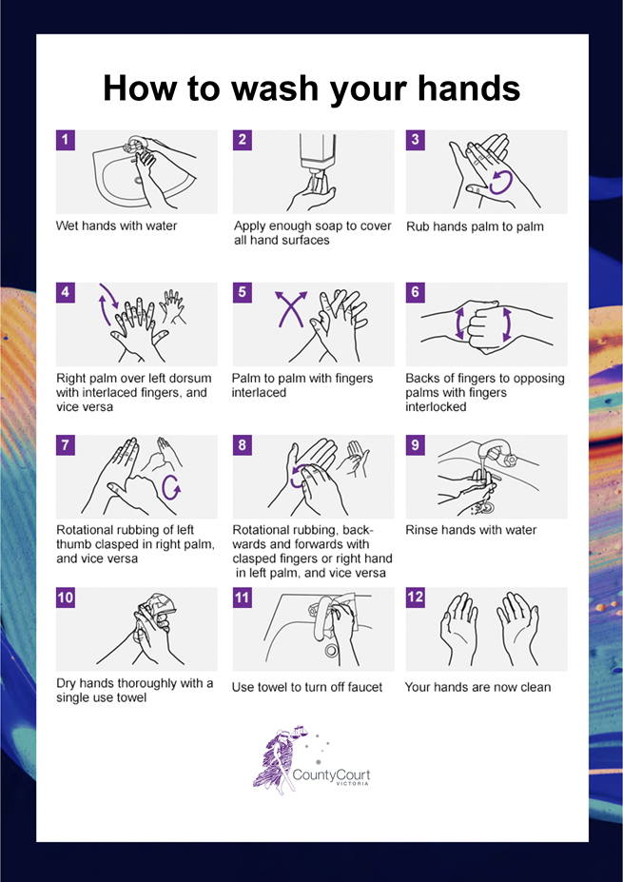

APPENDIX 2: Safe use of hand sanitiser protocol
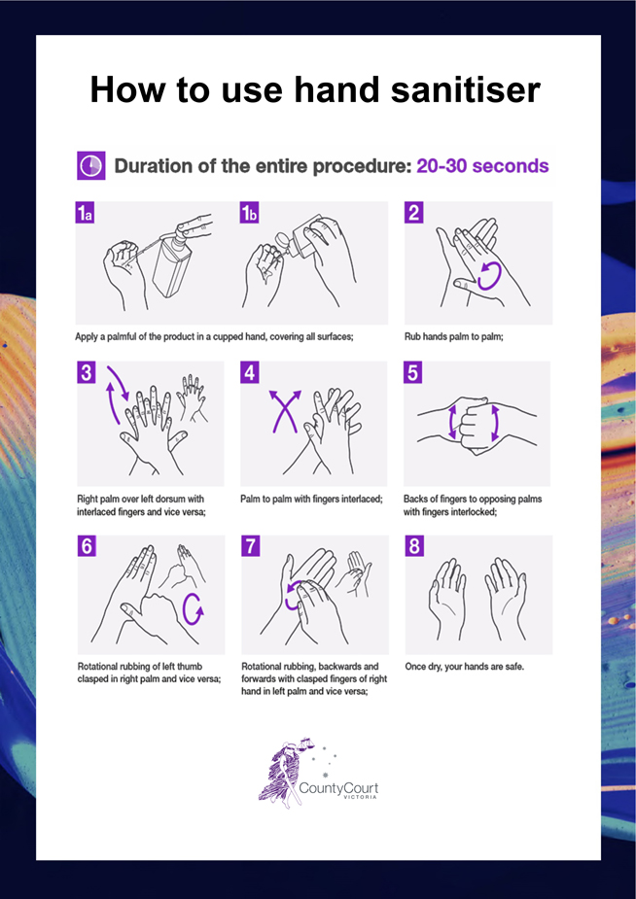

APPENDIX 3: Safe mask use and disposal protocol
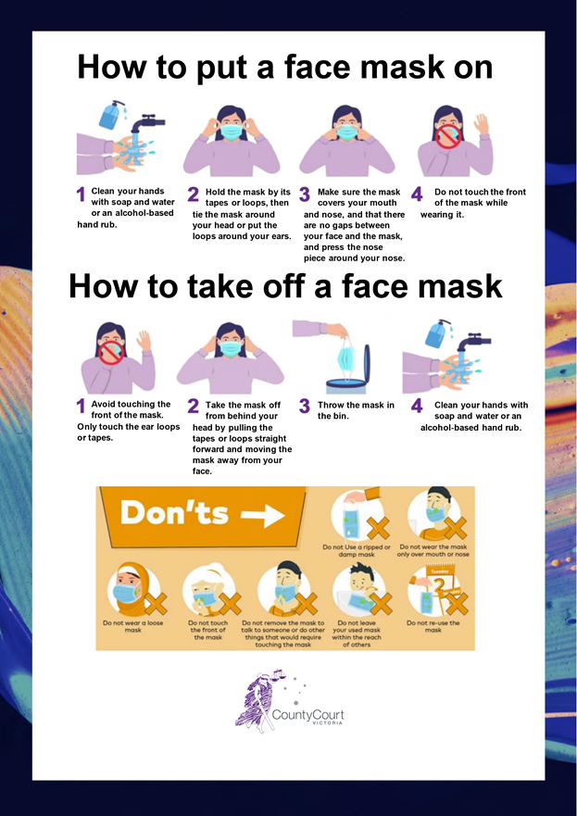
See ‘How to wear a mask’, Australian Government Department of Health: https://www.youtube.com/watch?v=rsBL0yTZNTMhttps://www.youtube.com/watch?v=rsBL0yTZNTM

APPENDIX 4: Safe glove use and disposal protocol
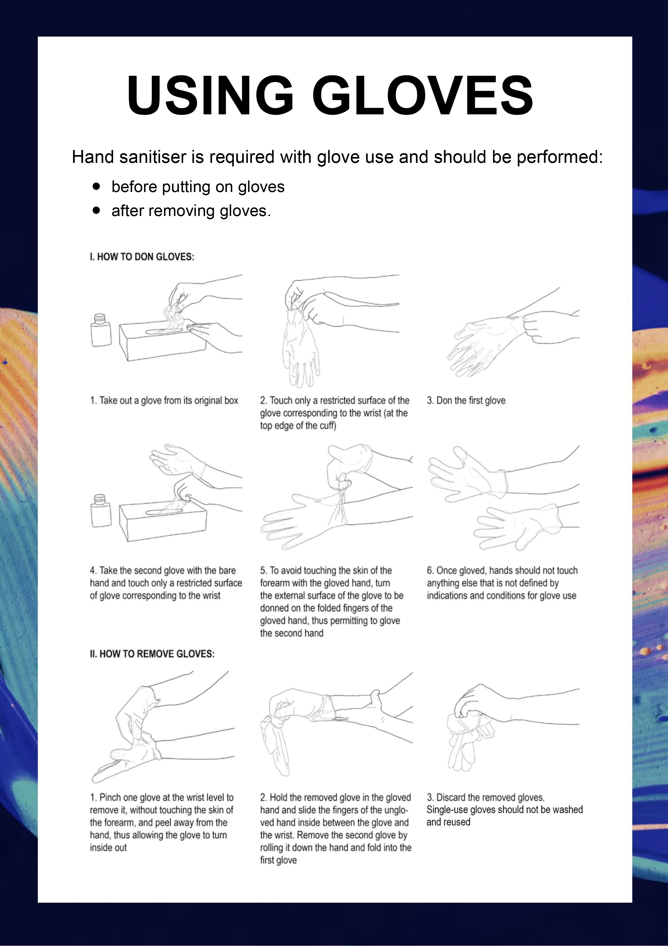
See Ansell’s video ‘How to properly remove single-use gloves’.

APPENDIX 5: Safe use of face shield protocol
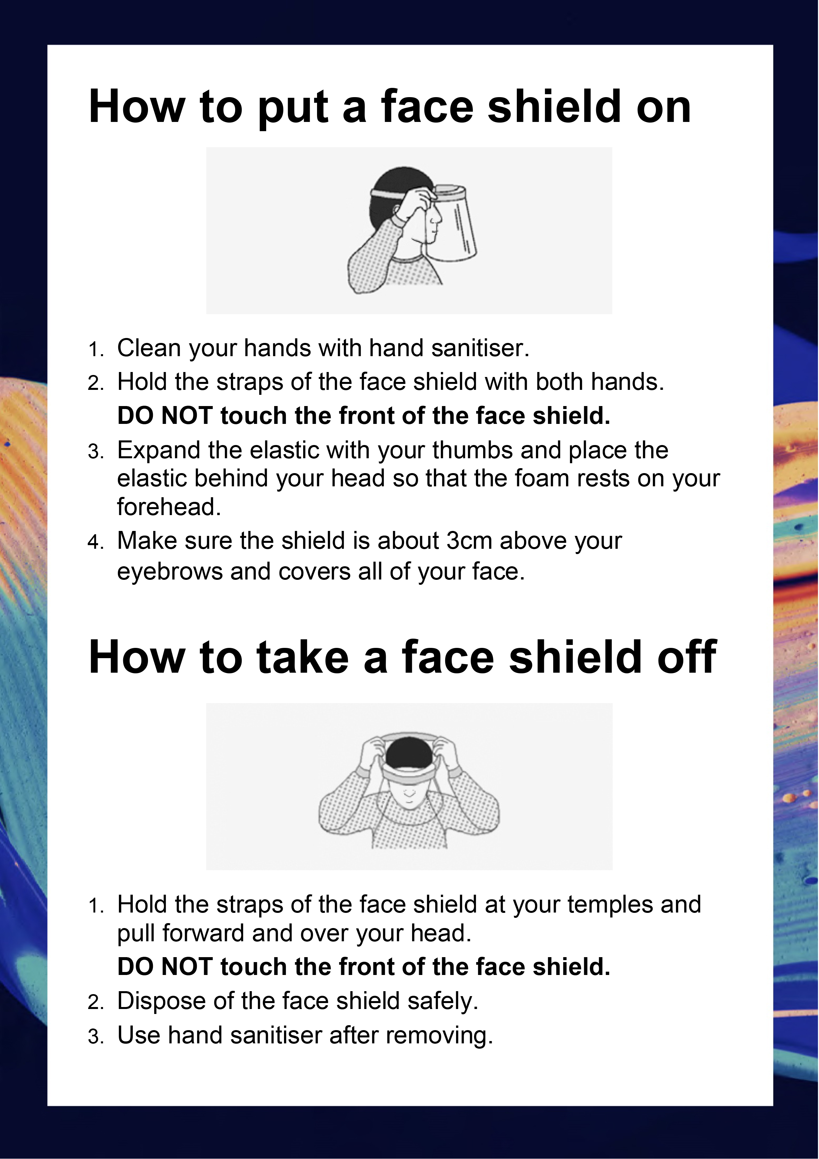

See ss 27(4)–(9) of the Juries Act 2000. NB: These sections are repealed on 26 October 2022.
Note, this protocol is only for use of face shields in the circumstances described in 3.4 regarding in-person witnesses on page 8.

