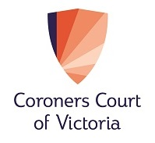

CORONERS COURT AND VICTORIAN BAR
DIRECT PRO BONO REFERRAL SCHEME (PILOT)

BARRISTER EXPRESSION OF INTEREST FORM

Name: …………………………………………………Silk: (yes/no)
Telephone:……………………………………………..
Email:…………………………………………………..
Current coronial practice: (yes/no)

Please return this form by email to: The Victorian Bar Pro Bono Coordinator at probono@vicbar.com.au or at Level 5, 205 William Street Melbourne 3000.

