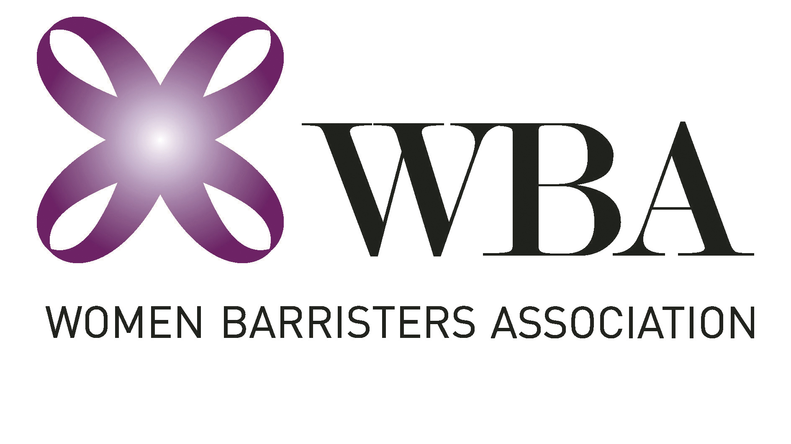

PROXY FOR AGM 2019

Choose one of:

I hereby authorise the Convenor, Kylie Weston-Scheuber, to vote on my behalf at the Annual General Meeting on Tuesday 9 June 2020.

OR

I hereby authorise the following WBA member to vote on my behalf at the Annual General Meeting on Tuesday 9 June 2020.

Name of authorised proxy: __________________________________

Name: ____________________________ Signature: __________________________

Dated: ____________________________

