COVID-19 response
Melbourne criminal jury trials where no physical distancing required – guide for the profession and court users

DOCUMENT CONTROL
Details
Document type | COVID-19 response
Reference | Melbourne criminal jury trials where no physical distancing required – guide for the profession and court users
Division | Criminal Division
Authorised by | His Honour Judge Mullaly (Head of the Criminal Division)
Notes | This Guide applies where:  - physical distancing and density quotas are not required in the courtroom when the courtroom is use for the ordinary operational purposes of the Court, including jury trials; and  - replaces the Recommencement of Melbourne criminal jury trials guide for judges and judicial staff version 6 published 14 April 2021.  If physical distancing, density quotas and any other health and safety measures are re-introduced, the County Court will seek expert health advice and may suspend the procedures in this Guide and re-introduce any, all or additional provisions in the Recommencement of Melbourne criminal jury trials guide for judges and judicial staff version 6 published 14 April 2021.

Release history
Version | Date | Author | Summary of changes
1 | 21 May 2021 | Winnie Wang | See ‘Notes’ section above.

CONTENTS
1. Melbourne criminal jury trials 4
Application of Guide 4
Criminal trial process 4
COVID-safe health and safety overlays principles 4
Mutual obligations to health and safety 4
Related documents and appendices 5
2. Juries Victoria measures 6
COVID-19 factsheet for jurors 6
Applications for excuse or deferral 6
Jury pool 6
3. General information 7
Masks 7
Mask setting 4 7
Court-provided disposable masks 7
Disposable gloves 8
Cleaning 8
Juror daily health screening questions 8
Expedited testing protocol 8
4. Pre-trial matters 10
5. Jury empanelment 11
Jury empanelment procedure 11
6. The jury trial in court 16
7. Guidelines if a trial is impacted by COVID-19 21
Association with tested person guide 21
Suspected case guide 22
Positive test guide 30
Expedited testing protocol 32
APPENDIX 1: Hand washing protocol 33
APPENDIX 2: Safe use of hand sanitiser protocol 34
APPENDIX 3: Safe mask use and disposal protocol 35
APPENDIX 4: Safe glove use and disposal protocol 36

Melbourne criminal jury trials

Application of Guide
  - This Guide:
    - applies where there is no physical distancing requirements in courtrooms or court facilities used for jury trials;
    - replaces the Recommencement of Melbourne criminal jury trials guide for the profession and court users version 6 published 14 April 2021.
  - If physical distancing, density quotas and any other health and safety measures are re-introduced, the County Court will seek expert health advice and may suspend the procedures in this Guide and re-introduce any, all or additional provisions in the Recommencement of Melbourne criminal jury trials guide for the profession and court users version 6 published 14 April 2021.

Criminal trial process
  - The pre-COVID criminal jury trial process will be adopted in so far as possible, but with the necessary COVID-safe overlays outlined in this Guide.
  - The pre-COVID criminal jury trial process means:
    - The Court will revert back to using in-person jury pools.
    - The jury panel will be brought up to the trial courtroom and empanelment will take place in-person in the trial courtroom. This means there will be no remote empanelment from the jury pool room.
    - Each courtroom’s adjoining jury room will be used by the jury during adjournments and deliberation and a paired courtroom will not be required.

COVID-safe health and safety overlays principles
  - The COVID-safe health and safety measures and overlays that remain are intended to comply with the Court’s duty under the Occupational Health and Safety Act 2004 (Vic) to ensure, so far as is reasonably practicable, the health and safety of judicial officers, staff, jurors and court users by:
    - eliminating risks to health and safety so far as is reasonably practicable
    - where it is not reasonably practicable to eliminate risks to health and safety, to reduce those risks so far as is reasonably practicable.
  - The measures outlined in this Guide are specific to jury trials.

Mutual obligations to health and safety
  - All participants in the jury trial will be apprised of, and where required appropriately reminded of, the mutual obligations of all participants to the health and safety of one another.
  - For example, jurors will be instructed that they have a responsibility to stay at home if they are unwell and not place the health and safety of judicial officers, court staff and other court users at risk.
  - All trial participants, including judges, court staff, jurors, counsel, practitioners, witnesses and any other persons permitted in the courtroom are asked to check the DHHS lists of exposure sites (https://www.dhhs.vic.gov.au/case-locations-and-outbreaks) on a daily basis to determine if they, or anyone they live with, or have contact with, may have been at risk of exposure.

Related documents and appendices
  - This guide should be read in conjunction with the following documents:
    - Hand washing protocol (See Appendix 1)
    - Safe use of hand sanitiser (see Appendix 2)
    - Safe mask use and disposal protocol (see Appendix 3)
    - Safe glove use and disposal protocol (see Appendix 4)
    - Safe face shield use and disposal protocol (see Appendix 5)
    - Court Services Victoria’s COVIDSafe Plan.

Juries Victoria measures

COVID-19 factsheet for jurors
  - A COVID-19 fact sheet will be sent to jurors with their Jury summons, advising them of the precautionary measures and guidelines for their attendance. This fact sheet is also available on the County Court, Supreme Court and Juries Victoria websites.
  - The factsheet includes advice that jurors are not to attend the Court, and must call Juries Victoria, if they:
    - feel unwell, or have any signs or symptoms of COVID-19
    - are awaiting test results for COVID-19
    - are required by public health authorities to take a COVID-19 test
    - are required by public health authorities to stay in quarantine or isolation
    - are required to stay at home because of a public health direction/advice.

Applications for excuse or deferral
  - In addition to the more commonplace reasons for deferral (such as pre-booked leave, small business ownership, etc.) Juries Victoria will give greater consideration to excusing or deferring persons who may be particularly vulnerable to the consequences of COVID-19, or who, for example, would have difficulty complying with the requirement to wear a mask, or have issues with providing consent or undergoing a COVID-19 test if required.

Jury pool
  - Up to 150 jurors may be assembled in-person in the jury pool room to provide jury panels.
  - While the pre-COVID process allowed up to 150 people to be brought in to form the jury pool, lower numbers may be brought in on any given date depending on the number of empanelments that occur on the same day, estimated trial length and number of accused in the trial.
  - As the Court reverts back to jury pools and in-person jury panels, the Court will monitor jury pool sizes, the number of empanelments that can occur on any one day and the time at which empanelment can proceed (that is, when a jury panel seated in the trial courtroom is ready for empanelment).

General information

Masks

Mask setting 4
  - For as long as this Guide applies, mask setting 4 will be in place.
  - During mask setting 4, masks are not required to be worn by all trial participants.
  - Trial participants may wear a mask if they wish, subject to the following:
    - those addressing the Court may choose to continue to wear a mask so long as they can be clearly heard and understood, at the discretion of the judge;
    - the accused will be required to remove a mask when pleading during the arraignment;
    - a juror will be required to briefly move a mask to one side, while holding the straps, during any callover and answering ‘present’ or ‘excuse’ during empanelment;
    - a juror will be required to remove a mask when addressing the Court during the provision of any verbal excuse, or when addressing to the Court regarding a written excuse;
    - a juror will be required to remove a mask during the striking of the jury.
  - If a person requires a new mask, they must use hand sanitiser before picking up and fitting a new mask.
  - Should instances of reported community transmission re-occur, urgent health advice will be sought with respect to both physical distancing and the immediate re-introduction of mask wearing, and at short notice the Court may require all trial participants to revert to mask settings 1, 2 or 3 (outlined in the Recommencement of Melbourne criminal jury trials guide for the profession and court users version 6 published 14 April 2021).

Court-provided disposable masks
  - Disposable masks will be available to all court users and those attending for jury duty and participating in a trial.
  - Jurors or trial participants arriving at the Court wearing their own mask (for example, a non-disposable mask) will be provided with a disposable mask by Juries Victoria staff, and asked to wear a disposable mask, to allow for ease of removal, disposal and for fresh mask(s) to be used throughout the empanelment process and trial. Jurors will be notified of this requirement by Juries Victoria staff in advance of their summons date.
  - Disposable masks will be available for jurors:
    - at entrance points before security screening
    - in the jury pool room
    - in the jury room.
  - Disposal bins and hand sanitiser will also be provided next to all masks distribution points to allow for safe mask use in accordance with the Safe mask use and disposal protocol (see Appendix 3).
  - In addition to the requirement that a new mask be worn whenever one is removed, on the advice that masks are to be refreshed every four hours, jurors and all court users will be provided with a fresh mask after any mid-sitting break in the sitting the juror wishes to wear a mask (see Appendix 3).
  - Supplies of additional masks and appropriate bins for safe mask disposal will be provided in the jury pool room trial courtroom and the jury room.

Disposable gloves
  - Disposable gloves will be available to judges, court staff, legal representatives and jurors participating in a trial. The gloves will be available:
    - on the judge’s bench (for the judge)
    - on the judicial staff bench (for judicial staff and jurors)
    - on the bar table (for legal representatives)
    - in the jury room (for jurors).
  - Hand sanitiser will also be provided next to gloves to allow for safe glove use and disposal in accordance with the Safe glove use and disposal protocol (see Appendix 4).

Cleaning
  - The Court has established an additional cleaning regime for the jury pool room, jury room, trial courtroom, deliberation area and jury bathroom with a focus on high touch points in areas used by multiple people. For example, high touch points in the witness box will be cleaned between witnesses.

Juror daily health screening questions
  - Upon entry to the Court building each day, jurors will be asked by a court security officer the following questions:
    - do you feel unwell, or have any signs or symptoms of COVID-19?
    - are you awaiting test results for COVID-19?
    - are you required by public health authorities to take a COVID-19 test?
    - are you required by public health authorities to stay in quarantine or isolation?
    - are you required to stay at home because of a public health direction/advice?

Expedited testing protocol
  - The Court and Court Services Victoria have developed an expedited testing protocol which will facilitate the testing of any trial participant for COVID-19, and the receipt of results within 24 hours.
  - It is anticipated that a trial would only require a maximum adjournment of one day in order to facilitate the testing and receipt of the results.
  - Jurors will be advised in advance of attendance at court that they will be asked to consent to a testing protocol if selected as a juror, although completing the consent forms (and ultimately any testing) is voluntary.
  - Parties will be provided in advance of the trial with consent forms to complete (if they wish) and send to the chambers of the presiding judge for safe retention, in the event that expedited testing of counsel, instructing solicitors or witnesses is required.

Pre-trial matters
  - It is suggested that, in addition to the usual matters, counsel should assist the Court by addressing the following matters, if not already raised with the judge’s chambers:
    - confirming witness arrangements particularly with regard to those witnesses that will appear remotely using videolinks
    - whether an interpreter is required for the accused or any witness
    - whether a view is required and what assessment has been made of the capacity to conduct a view with appropriate distancing/density
    - confirming with the Court the anticipated desire of family or supports to attend the trial and that specific arrangements for limited in-court or remote viewing will need to be made.

Jury empanelment
  - Extended jury boxes will remain in those courtrooms which had their jury boxes extended to facilitate 1.5m physical distancing. This is so the Court can efficiently revert to the paired courtroom approach if physical distancing and density quotas are re-introduced.

Jury empanelment procedure
  - The pre-existing pre-COVID procedure is to take place with the following COVID-safe overlays:
Event | Procedure
Panel arrives at court | As members of the panel arrive at Court, and register with Juries Victoria staff they will be directed to answer the following health screening questions:  - do you feel unwell, or have any signs or symptoms of COVID-19?  - are you awaiting test results for COVID-19?  - are you required by public health authorities to take a COVID-19 test?  - are you required by public health authorities to stay in quarantine or isolation?  - are you required to stay at home because of a public health direction/advice?  If the panel members answers ‘no’ to each question, they will be directed by Juries Victoria staff to sit in their assigned seat in the jury pool room.  If the panel member answers ‘yes’ to any of the questions, they will not enter the pool room, and will be directed to isolate and/or seek medical assistance as required.  If a juror arrives wearing their own mask, they will be provided with a disposable mask.  If a juror passes the health screening questions, the juror is admitted to the pool room.
Jurors go to jury pool room and take numbered seat | Under Mask Setting 4, masks are not required to be worn, but jurors may wear a mask if they wish. Jurors wearing a non-disposable mask, or their own personal mask, will be provided with and asked to wear a disposable mask, to allow for ease of removal, disposal and for fresh mask(s) to be used throughout the empanelment process and trial if selected as a juror.  Up to 150 jurors may be assembled to provide panels.  Signs, floor stickers guide way to pool room.  Signs outside and inside pool room with information on hygiene, sanitiser availability and coughing etiquette, mask use and disposal, glove use and disposal.  The juror is provided a slip of paper indicating their panel number. Safe glove use and disposal protocol (see Appendix 4) used.  Jurors seated in their numbered chairs.
Jurors in pool room given induction/orientation | Maximum 150 jurors in jury pool room.  2 Juries Victoria staff present.  Jurors given briefing on hygiene, COVID safety measures, limiting exposure outside the court, bathroom location, testing protocol and requirement to complete testing consent forms if selected as a juror.  Jurors asked to use only assigned seat and not wander around the room.
Jurors balloted onto panels | Juror numbers are balloted to form panels of between 30 and 45 jurors.  Jurors selected on a panel assemble in the hallway in front of the jury pool room.  Jurors wearing a mask will be asked to use hand sanitiser and select further masks to bring with them to wear, if they wish to, after having disposed of their mask when required to remove it during empanelment.
Overnight cleaning of jury pool room | Entire jury pool room cleaned and disinfected overnight.
Jury panel members seated in the courtroom with other trial participants | Jurors instructed to only use same seat during empanelment.
If required, jurors check list of trial witnesses and parties | If list is required, tipstaff / associate places lists on jury panel seats in courtroom before empanelment, so there is no need for associate to move among jurors to distribute them.  Gloves used when distributing lists.  Safe glove use and disposal protocol (see Appendix 4) followed.  Lists left at seats and collected with gloves (and disposed of) after remaining jury panel has been discharged and left at conclusion of empanelment.  Safe glove use and disposal protocol (see Appendix 4) followed.
Judge opens court | Judge confirms with counsel any outstanding issues and whether ready for the panel,
Court adjourns | Tipstaff / associate picks up jury from jury pool room and move to trial court.  Tipstaff/associate hold jurors outside to confirm court ready.  Jurors move in and take seats.  Tipstaff/associate provide pre-empanelment brief/demonstration as per the judge’s practice.  Tipstaff/associate advices judge court is ready.
Judge opens court | Judge, court staff, legal counsel, instructing solicitors, accused and Corrections officer(s) and
Provision of juror panel number cards | Juries Victoria officer provides juror panel number cards to the associate.  Safe glove use and disposal protocol (see Appendix 4) followed after delivery of juror panel number cards.  Associate receives juror panel number cards.  Associate uses gloves/hand sanitiser.
Initial callover (if required) | If required by the presiding judge, an initial callover is conducted, with each juror in attendance responding ‘present’. If a juror chooses to wear a mask, they must move the mask to one side if required by the presiding judge.
Directions to jury panel | Judge provides introductory remarks to the jury panel on the process of empanelment, and COVID-19 safety throughout the process.  Judge provides usual information (see s 32 of Juries Act).
Arraignment of accused | Accused remain(s) in the dock while arraigned.  If an accused wishes to wear a mask, they must remove their mask for the arraignment and dispose of the mask in the bin in front of dock (provided).  After the accused is/are arraigned, they may wish to use hand sanitiser (provided) and fit a new mask (provided).
Call over of jury panel | Associate calls over the panel.  Jury panel members stand at their allocated seat.  Jury panel members respond with ‘Present’ or ‘Excuse’ during callover.  If a juror has chosen to wear a mask and where required by judge, jurors will be requested to move their mask to one side, or briefly take it off, using the mask straps, while answering the callover.
Taking of excuses | Judge advises panel members that the Court will now hear excuses, and sensitive excuse may be provided in writing.  Any juror seeking to be excused who is wearing a mask must remove mask and dispose of it in the bin (provided).  Judge advises juror that sensitive excuse may be provided in writing, if panel member indicates this is required.  If verbal:  - if judge requires juror to give oath for purpose of seeking excuse, religious texts not used;  - judge hears and determines excuse;  If written:  - panel member is asked to use hand sanitiser, select pen, then write excuse on the paper provided, fold and hand to the tipstaff, before placing pen in used pen box (provided);  - Tipstaff hands excuse to the judge following Safe glove use and disposal protocol (see Appendix 4);  - Written excuse is received by judge and then considered.
Striking the jury | Defence counsel asks permission for instructing solicitor to stand/sit beside accused in the dock.  Associate uses gloves to ballot jurors or uses hand sanitiser after ballot.  If juror’s number called, juror stands and performs the parade in the manner as directed by the judge, to be seated in the jury box.  Juror walks around courtroom past the dock, or alternatively, stands and turns to the dock, at the preference of the presiding judge.  If a juror is wearing a mask, they must remove the mask and dispose of it in the bin provided prior to the parade.  If selected, a juror wishing to wear a mask may put the additional mask brought with them on after being seated in the jury box.
Challenged juror returns to seat | If juror challenged or asked to stand aside, the juror returns to the same seat they occupied in the courtroom.  A juror wishing to wear a mask may put the additional mask brought with them on after being seated in the courtroom.
Empanelled jurors sworn in as jury | Jurors asked to stand and give an oath or make an affirmation.  Judge advises jurors that they may swear an oath or make a promise, or take an affirmation (with explanation as to the difference) and that, as a religious text will not be provided, this is not needed for an oath to have full force and effect.  If giving an oath, religious texts will not be used.  - If a person wishing to swear an oath declines to do so without a religious text, they will be required by the judge to affirm.  Judge instructs the associate to swear in the jury.  Jurors sworn in.
Remaining panel members discharged | Judge discharges the remainder of the panel.
Discharged panel members return to the jury pool room | Unselected jurors are escorted back to the jury pool room by a Juries Victoria officer at the conclusion of empanelment.  Jurors move through the public area, using public lifts.  Jurors are instructed to resume the same numbered seat that they previously occupied while in the jury pool room.

The jury trial in court
  - The following table outlines modified procedures to support the health and safety of judges, staff, jurors and court users from commencement of the trial to verdict.
Event | Procedure
First adjournment after jury sworn in | The court is adjourned to allow jurors to visit and familiarise themselves with jury room (under instruction of Tipstaff) and have bathroom break.
Initial directions to the jury following adjournment | Court resumes after adjournment.  Jurors provided usual initial directions, in addition, provided directions on COVID safety including:  - Importance of maintaining the same seat in the Jury Room and in the Trial Courtroom when they first return after choosing a foreperson.  - Importance of cough etiquette and hand hygiene.  - Importance of reporting if they experience symptoms at any time and to contact the court before coming in if symptomatic.  - Importance of minimising their risk of exposure outside of court.
Directions for choosing foreperson | When considered appropriate by the presiding judge, the jury is asked to choose a foreperson.  This should occur at a time so as to allow for overnight cleaning, before re-seating of the jury (i.e. the jury may be asked at the conclusion of one day to appoint a foreperson before commencing the following day).
Jury takes assigned seats for trial after choosing foreperson | Jury seats in court to be numbered on floor (not visible outside of the jury box) to help orient jurors and ensure they occupy the same seat.  Tipstaff directs jury into trial courtroom and directs foreperson to sit in the appropriate seat.  Judge reminds jury to keep those final assigned seats throughout the entire trial.
Jury travels to and arrives at CCV for each day of trial | Travel costs reimbursed so that jurors do not travel to and from court using public transport (to 30 June 2021).  Jury move to jury room.  If required, lift protocol followed (following maximum capacity of persons per lift).  On arrival into the Court each day, security staff ask jurors if they answer ‘yes’ to any of the screening questions, on a poster, as follows:  - Do you feel unwell, or have any signs or symptoms of COVID-19?  - Are you awaiting test results for COVID-19?  - Are you required by public health authorities to take a COVID test?  - Are you required by public health authorities to stay in quarantine or isolation?  - Are you required to stay at home because of a public health direction/advice?  NOTE  For efficiency in the entry of empanelled jurors, the questions will be displayed on a prominent poster-sized sign, and Juries Victoria staff will ask the attending juror if they answer ‘yes’ to any of the questions.  If yes to any of the five questions, the juror should not enter and is given referral for testing as appropriate.  If a juror is required to be tested or to isolate, the judge is informed so they can make decision about adjournment/discharge.
Jury enters trial courtroom | Following choosing of foreperson, jurors are allocated a seat for the duration of the trial and asked to use the same seat throughout.  Each juror supplied with a small bottle of hand sanitiser they can keep on them.
Jury sits through session and is shown exhibits and other evidence | Exhibits and other evidence that the jury is required to touch are minimised.  Where there are physical exhibits, staff, lawyers, witnesses and jurors are provided with gloves to handle.  Safe glove use and disposal protocol (see Appendix 4) followed.  Each juror provided with individual copies of documentary evidence, rather than shared folders. This minimises contact between jurors.
Jury provided with tablets for appropriate trials | For State prosecuted matters, where there are large volumes of written material or electronic exhibits to be provided to jurors, individual juror tablets may be used.  Tablets will be provided to the jury wiped down and sanitised.  At a time decided by the presiding judge, there may be a short adjournment to enable the tipstaff/associate to distribute the tablets to each juror (following the Safe Glove Use and Disposal Protocol) by placing the tablet on the juror’s seat during the adjournment period.  Judge advises the jury that:  - Tablets will be used during the trial to show exhibits and material.  - There will be a short adjournment to enable distribution of the tablets and when juror’s return to the courtroom, there will be a tablet on their seat.  - Juror must only use the tablet assigned to them.  - Tablet must not be shared between jurors.  - Jurors should not seek to provide technical support for one another.  - Tablets have been sanitised, but jurors may wish to use the specific sanitising wipes for tablets, available in the jury room courtroom.  - Jurors will be shown how to use the tablets.  - Written user instructions will be available on the tablets which jurors can refer to. If a juror requires further technical support at any point during the trial, they should seek to raise the issue via a written jury question.  Each juror must only use the tablet assigned to them for the duration of the trial.  Jurors will be shown how to use the tablets and written user instructions will be available on the tablets for reference.  If a juror requires technical support at any point during the trial, ordinarily the technical support will be provided in open court. When technical support is provided which involves touching the tablet, the technician will follow the Safe Glove Use and Disposal Protocol.
Wearing of masks not required by trial participants (under ‘mask setting 4’) | During mask setting 4, masks are not required to be worn by all trial participants.  Trial participants may wear a mask if they wish, subject to the following:  - those addressing the court may choose to continue to wear a mask so long as they can be clearly heard and understood, at the discretion of the judge;  - the accused will be required to remove a mask when pleading during the arraignment;  - a juror will be required to briefly move a mask to one side, while holding the straps, during any callover and answering ‘present’ or ‘excuse’;  - a juror will be required to remove a mask when addressing the Court during the provision of any verbal excuse, or when addressing to the Court regarding a written excuse;  - a juror will be required to remove a mask during the striking of the jury.  If a person requires a new mask, they must use hand sanitiser before picking up and fitting a new mask.  Should instances of reported community transmission re-occur, urgent health advice will be sought with respect to the immediate re-introduction of mask wearing, and at short notice the Court may require all trial participants to revert to mask settings 1, 2 or 3.
Witness called to give evidence (‘mask setting 4’) | Vulnerable witnesses may give evidence remotely.  Where practicable and appropriate, other witnesses may still give evidence remotely.  During mask setting 4, a witness is not required to wear a mask.  If giving an oath, religious texts not used and judge to advise swearing without text.  Witness box cleaned and disinfected between in-person witnesses by cleaners – allow 10 mins to be effective.  Tipstaff to wipe down screen in the witness box using sanitising wipes where the trial is an e-trial.
Jury breaks for morning/afternoon break or lunch | Jurors are not confined at lunchtime – they may go for a walk, but they are reminded to limit their exposure.
Jury returns to court after break or lunch and trial continues | Jury assembles in jury room, and staff member then directs them into the trial courtroom.  Jurors sit in their allocated seats.
Jury retires for the day | Before leaving for the day, jurors reminded to limit their exposure outside the court.  Staff member directs jurors into the deliberation room to collect their things, then jurors leave CCV, maintaining distance.  Court keeps a record of who was in the courtroom each day (jurors identified by number).  Courtroom and jury room are cleaned before the start of next day.
If off-site view conducted | Travel to location and back on bus or buses.  Jurors and staff asked to return to same seat.  Location of view cleared of other people.  Hand sanitiser made available on buses and on site.
At conclusion of trial, jury deliberates | Cleaning and disinfection of jury room to continue, with jury materials not visible to cleaners.  Staff remind jury about hygiene.  Jurors are provided with individual meals so as to avoid shared items.  Jury keepers are outside the jury room, in the trial courtroom.  During deliberation, individually wrapped lunches will be provided to jurors delivered to the jury room.
Jury questions | Jurors return to trial courtroom and resume same seats.  Question written down and handed to the judge via the associate (staff wear gloves).  Safe glove use and disposal protocol (see Appendix 4) followed after delivery of written question.  Jurors may need to return to jury room during discussion with Counsel.  Jurors return to trial courtroom to same seats and judge provides answer to their question or directs them further.
Verdict | Jury indicates they have verdict to the jury keeper.  Jury brought into the trial courtroom.  Once verdict given jury discharged and return to collect belongings from the jury room and leave CCV.

Guidelines if a trial is impacted by COVID-19
  - This set of guides outlines the actions to be taken in the event a trial is impacted by one of the following:
    - a trial participant being associated with a tested person (where the result is not yet known)
    - a suspected case of COVID-19
    - a confirmed case of COVID-19.

Association with tested person guide
  - If a person is associated with a person being tested, the person does not need to isolate (Scenario A), unless the person being tested is a contact of a known positive case (Scenario B).
  - Scenario A
Tested Person | → | Person Associated with Tested Person  (Isolation not required)

  - Scenario B
Positive Case | → | Tested Person | → | Person Associated with Tested Person  (Isolation pending results required)

  - The following table outlines the process to be actioned for Scenario B, if a trial participant advises that they are associated with a person (‘Tested Person’) and the Tested person is a contact of a known positive case.
  - A person will be an ‘Associated Person’ if they meet one of the following criteria:
    - had face-to-face contact with the Tested Person
    - shared a closed space with the Tested Person (this would include working in close proximity with the Tested Person)
    - live in a household with the Tested Person.
Scenario B | Actions
Judge, staff member, juror, counsel, practitioner or witness reports they are associated with a Tested Person (where the result is not yet known) | Notification  Juror notifies Juries Victoria by phone (if at home) or notifies tipstaff or Juries Victoria staff (if at the Court) that they are an Associated Person.  Judge, staff member, counsel, practitioner or witness reports they are Associated Person.  The Associated Person should not attend the court facility.  If already at the Court, the judge, staff member, counsel, practitioner or witness should leave the court facility if they become aware that they are an Associated Person. Accident Incident Report to be completed using the Accident Incident Reporting System (AIRs).  If already at the Court, the juror should be isolated in a room by Juries Victoria staff (or tipstaff) until they receive further instruction from the judge. Accident Incident Report to be completed using the Accident Incident Reporting System (AIRs).  Judge should notify the Head of Criminal Division.  Head of Division will notify associate/s and tipstaff, if not already notified.  Directions to jurors and parties  Judge to determine whether the trial should be adjourned sine die and ask the Associated Person to remain in isolation until test results of the Tested Person received or whether to discharge the jury.  Associate to follow usual processes and make appropriate notifications to Juries Victoria and the relevant Registry staff in accordance with the judge’s decision.  Adjournment  If the trial is adjourned and if the Associated Person’s test results return negative, the associate is to liaise with the parties and the relevant Registry to staff arrange for the trial to be relisted if directed to do so by the judge.  Associate to notify the parties and Juries Victoria staff of the resumption date once confirmed.  Juries Victoria staff to notify jurors of the resumption date.  If the trial is adjourned and if test results return positive, it is likely that the Associated Person will need to be tested, and the ‘Suspected case guide’ (see ‘Any person tested for COVID-19 during the trial’ in the ‘Suspected Case Guide’).

Suspected case guide
  - The following table outlines the process to be actioned if the Court receives notification that a person is experiencing symptoms associated with COVID-19.
Scenario | Actions
Juror reports being symptomatic | Notification  Jurors are instructed by the judge that they should not attend the court facility if they are experiencing symptoms.  Juror symptomatic at home  Jurors instructed that they should contact Juries Victoria as early as possible (on the number provided) to advise if they will not be attending and provide reasons.  If Juries Victoria staff receive notification that a juror will not be attending due to being symptomatic, Juries Victoria staff to advise the Chief Judge and the judge.  Juror symptomatic at screening  If any juror reports experiencing symptoms at the entry screening questions by a Juries Victoria staff member, Juries Victoria staff to isolate the juror, and advise the Chief Judge and the judge. Accident Incident Report to be completed using the Accident Incident Reporting System (AIRs).  Juror symptomatic while at court  If juror reports experiencing symptoms during the trial, the tipstaff removes the juror from the jury room (or other location) and escorts them to an empty meeting room on the same floor of the court facility (maintaining appropriate distancing), and advises the juror to remain in the room until they receive further instruction. Accident Incident Report to be completed using the Accident Incident Reporting System (AIRs).  Tipstaff notifies judge and associate (where relevant) that a juror has reported being symptomatic.  Judge alerts the Head of Criminal Division that their trial has been disrupted due to a juror being symptomatic.  Associate notifies Juries Victoria staff that a juror has reported being symptomatic and advises of the juror’s location.  Testing  Juries Victoria arrange for a referral for testing (using the Expedited testing protocol).  If juror did not attend the court and is at home, Juries Victoria staff will advise the juror that they will be receiving a call from Court Services Victoria to facilitate the testing process.  If the juror is at the court facility, Juries Victoria staff to attend to the juror’s location (maintaining appropriate distancing) and advise that a qualified person will be in touch via telephone to facilitate testing (see Expedited testing protocol).  Juries Victoria staff to advise the Facilities team of the meeting room in which the juror is/was located for the purpose of cleaning once the juror departs.  Testing of the juror will be conducted in accordance with the Expedited testing protocol.  Directions to jurors and parties  Judge to determine whether the trial should be adjourned sine die until test results are received or whether to discharge the jury.  The Court will reconvene in the absence of the jury, and the judge will advise the parties of their intended course of action and invite submissions.  Decision regarding the future conduct of the trial will be announced in the presence of the jury and direction given.  Associate to follow usual processes and make appropriate notifications to Juries Victoria and Criminal/Civil Listings staff in accordance with the judge’s decision  If the trial is to continue, the judge is to advise remaining jurors and parties of additional cleaning arrangements.  Adjournment  If the trial is adjourned and if test results return negative, the associate to arrange for the trial to be relisted when directed to do so by the judge.  Associate to notify the parties and Juries Victoria staff of the resumption date  Juries Victoria will notify jurors of the resumption date.  If the trial is adjourned and if test results return positive, see Positive test guide.  Cleaning  If the person being tested has occupied any part of the building after an overnight cleaning, the trial courtroom, jury room and all spaces occupied by the symptomatic person will be cleaned.
Counsel reports being symptomatic during trial | Notification  Counsel must not attend the court facility if they are experiencing symptoms and should report experiencing symptoms at any stage during the trial.  Counsel must contact the judge’s chambers as soon as possible (by email or on a number provided) to advise if they are symptomatic and will not be attending. Accident Incident Report to be completed using the Accident Incident Reporting System (AIRs).  Associate to advise the judge that counsel has reported being symptomatic and will not be attending.  Judge notifies the Head of Criminal Division that their trial has been disrupted due to counsel being symptomatic.  Testing  Associate for the judge contacts Court Services Victoria in compliance with the Expedited testing protocol to seek referral for urgent testing of counsel.  Head of Criminal Division to advise judge that notification has been received.  Directions to jurors and parties  Judge to adjourn sine die until test results received.  The Court to reconvene in the absence of the jury to discuss the future conduct of the trial with impacted counsel appearing remotely via telephone or videolink, where health status allows.  After hearing from counsel, decision regarding the future conduct of the trial will be announced in the presence of the jury and appropriate directions provided.  Associate to follow usual processes and make appropriate notifications to Juries Victoria and the relevant Registry staff in accordance with the judge’s decision.  The judge to advise jurors and parties of additional cleaning arrangements.  Adjournment  If test results return negative, the associate is to arrange for the trial to be relisted.  Associate to notify the parties and Juries Victoria staff of the resumption date and time.  Juries Victoria will notify jurors of the resumption date.  If test results return positive, see Positive test guide.  Cleaning  If the person being tested has occupied any part of the building after an overnight cleaning, the trial courtroom and all spaces occupied by the symptomatic person will be cleaned.
Instructing solicitor reports being symptomatic during a trial | Notification  Solicitors must not attend the court facility if they are experiencing symptoms.  If their instructing solicitor reports being symptomatic, counsel must advise the associate and opposing counsel via telephone or email; or alternatively, advise the judge when court resumes in the absence of the jury. Accident Incident Report to be completed using the Accident Incident Reporting System (AIRs).  Testing  Judge to enquire with counsel whether the instructing solicitor intends to undergo testing for COVID-19.  Judge to request that counsel advise the Court when the result from any testing is received.  If test results return positive, see Positive test guide.  Directions to jurors and parties  Judge to determine whether the trial can continue, should be adjourned sine die until test results received or whether to discharge the jury.  Judge to consider whether it is appropriate to advise the jury that an instructing solicitor has reported being symptomatic and is undergoing testing.  Adjournment  If test results return negative, the associate is to arrange for the trial to be relisted.  Associate to notify the parties and Juries Victoria staff of the resumption date and time.  Juries Victoria will notify jurors of the resumption date.  Cleaning  If the person being tested has occupied any part of the building after an overnight cleaning, the trial courtroom and all spaces occupied by the symptomatic person will be cleaned.
Witness reports being symptomatic during trial | Notification  Counsel are directed by the judge to advise witnesses who are scheduled to give evidence that they are not to attend the court facility if they are experiencing symptoms.  Counsel are directed to notify the associate and opposing counsel via telephone or email as soon as they are aware that their witness will be unable to attend to give evidence, as scheduled; or alternatively, advise the judge when court resumes in the absence of the jury. Accident Incident Report to be completed using the Accident Incident Reporting System (AIRs).  If a witness has been sworn in, and their evidence carries over into a second day, before excusing the witness, the judge should remind the witness that they are not to attend the court facility if they begin to experience symptoms overnight.  Witness directed to notify relevant counsel if they are unable to attend court to continue giving evidence due to becoming symptomatic overnight.  Counsel are directed to notify the associate and opposing counsel via telephone or email as soon as they are aware that a witness will be unable to attend to give evidence, as scheduled; or alternatively, advise the judge when court resumes in the absence of the jury. Accident Incident Report to be completed using the Accident Incident Reporting System (AIRs).  Testing  If the witness has attended the court facility and commenced giving evidence, judge to request the witness undergo testing for COVID-19.  Judge (or delegate) will provide information to the witness regarding expedited testing and locations (see Expedited testing protocol).  Judge directs the witness to advise relevant counsel when the test has been performed, and to provide the results once received.  Counsel directed by the judge to advise the associate by telephone or email once notification received from the witness that the test has been performed, and to provide the results once received.  If test results return positive, see Positive test guide.  Directions to jurors and parties  If the health status of the witness allows, judge to consider whether appropriate in the circumstances to have the witness give (or continue giving) evidence via videolink.  Judge to consider whether it is appropriate to advise the jury that witness has reported being symptomatic and is undergoing testing.  If the witness has already attended in person and commenced giving evidence, judge to consider whether trial should be adjourned sine die until test results are received or whether to discharge the jury.  Cleaning  If the person being tested has occupied any part of the building after an overnight cleaning, the trial courtroom and all spaces occupied by the symptomatic person will be cleaned.
Accused on bail reports being symptomatic | Notification  Accused persons on bail are instructed by the judge that they should not attend the court facility if they are experiencing symptoms.  Accused instructed that they should contact their legal representatives as early as possible to advise if they will not be attending and provide reasons.  Counsel instructed by the judge that if the accused reports being symptomatic, they should advise the associate and opposing counsel via telephone or email as soon as possible or advise the judge when court resumes in the absence of the jury. Accident Incident Report to be completed using the Accident Incident Reporting System (AIRs).  Where the health status of the accused allows, the accused is required to appear remotely via telephone.  Judge to alert the Head of Criminal Division that their trial has been disrupted due to an accused person being symptomatic.  Testing  Judge to request the accused undergo testing for COVID-19.  Judge (or delegate) will provide information to the accused regarding expedited testing and locations (see Expedited testing protocol).  Judge directs the accused to advise their legal representatives when the test has been performed, and to provide the results once received.  The accused’s legal representatives to be directed by the judge to advise the associate by telephone or email once notification received from the accused that the test has been performed, and to provide the results once received.  Directions to jurors and parties  Judge to determine whether the trial should be adjourned to a fixed date until test results received or whether to discharge the jury.  The court will reconvene in the absence of the jury and judge will advise the parties of their intended course of action and invite submissions.  Decision regarding the future conduct of the trial will be announced in the presence of the jury and direction given.  Judge to consider whether it is appropriate to advise the jury that the accused has reported being symptomatic and is undergoing testing.  Where relevant, the judge is to consider appropriate orders regarding extension of the accused bail.  Associate to follow usual processes and make appropriate notifications to Juries Victoria and the relevant Registry staff in accordance with the judge’s decision.  Adjournment  If the trial is adjourned and if test results return negative, associate to arrange for the trial to be relisted.  Associate to notify the parties and Juries Victoria staff of the resumption date.  Juries Victoria will notify jurors of the resumption date.  If test results return positive, see the Positive test guide.  Cleaning  If the person being tested has occupied any part of the building after an overnight cleaning, the trial courtroom and all spaces occupied by the symptomatic person will be cleaned.
Accused in custody reported being symptomatic | Notification  Corrections Victoria to notify the chambers of the judge if an accused person in custody has reported being symptomatic at any stage during the trial and whether they have undergone testing for COVID-19. Accident Incident Report to be completed using the Accident Incident Reporting System (AIRs).  If required, and if the health status of the accused permits, the accused may appear remotely via videolink to discuss future conduct of the trial.  Judge alerts the Head of Criminal Division that their trial has been disrupted due to the accused being symptomatic.  Testing  The chambers of the judge to request that Corrections Victoria convey the test results of the accused to the Court once received.  Directions to jurors and parties  To be conducted in accordance with the ‘Accused on bail reports being symptomatic’ guidelines in this table (with any necessary modification).  Cleaning  If the person being tested has occupied any part of the building after an overnight cleaning, the trial courtroom and all spaces occupied by the symptomatic person will be cleaned.
Corrections Victoria staff report being symptomatic during a trial | Notification  Judge’s chambers receive notification from Corrections Victoria that a custody officer that has spent time in a particular courtroom has reported being symptomatic and has been directed to undergo testing for COVID-19. Accident Incident Report to be completed using the Accident Incident Reporting System (AIRs).  Judge’s chambers to notify the Head of Criminal Division.  Testing  Judge’s chambers to request that the results from the testing be conveyed to the Court when received.  If notified that test results positive, see the Positive test guide.  Directions to jurors and parties  Judge to advise the parties in the absence of the jury that a Corrections Victoria custody officer has reported being symptomatic and is undergoing testing.  Judge to consider whether it is appropriate to advise the jury that the custody officer has reported being symptomatic and is undergoing testing  Judge to determine whether the trial should proceed or be adjourned sine die until test results received.  Cleaning  If the person being tested has occupied any part of the building after an overnight cleaning, the trial courtroom and all spaces occupied by the symptomatic person will need to be cleaned.
Any person tested for COVID-19 during the trial | Notification  If any of the trial participants identified above are tested for COVID-19, they will be directed to self-isolate until they receive the results, and are therefore unable to attend the court facility, all appropriate notifications, testing and directions as per the above guidelines are to be applied, with any necessary modifications. Accident Incident Report to be completed using the Accident Incident Reporting System (AIRs).
Any person directed by DHHS to self-isolate during the trial | Notification  If any of the trial participants identified above are determined by Department of Health and Human Safety (DHHS) to be a close contact of a person diagnosed with COVID-19, are directed to self-isolate for a period of 14 days, and are therefore unable to attend the court facility, all appropriate notifications, testing and directions as per the above guidelines are to be applied, with any necessary modifications. Accident Incident Report to be completed using the Accident Incident Reporting System (AIRs).

Positive test guide
  - The following table outlines the process to be actioned if the Court receives notification that a person has subsequently returned a positive test for COVID-19 during a trial.
Scenario | Actions
Juror diagnosed with COVID-19 during the trial (while trial is adjourned waiting test results) | Notifications  Juries Victoria staff to notify the presiding judge, Chief Judge and Head of Criminal Division if a juror subsequently returns a positive diagnosis for COVID-19.  Juries Victoria staff (or delegate/s) to notify remaining jurors that a juror has returned a positive diagnosis and that further health information and testing advice from Department of Health and Human Safety (DHHS) will be forthcoming.  All necessary County Court Accident Incident Report (using the Accident Incident Reporting System (AIRs)) and WorkSafe notifications must be made. Health and Safety Representatives (HSRs) to be notified.  Contact tracing and testing  Juries Victoria staff to liaise with DHHS to conduct contact tracing and assist to identify all persons considered a close contact with the juror in the 48 hours prior to becoming symptomatic.  Chief Judge’s chambers or Senior Administrator Criminal Division to liaise with Juries Victoria and DHHS to provide relevant details of judges and court staff determined to be close contacts.  Judges and other court staff identified as close contacts must follow the advice of DHHS regarding testing for COVID-19 and the need to self-isolate.  Judges and other court staff must notify the Chief Judge and Head of Criminal Division, or their relevant manager or director of the test results once received.  Directions to jurors and parties  Judge will discharge the jury and advise Juries Victoria staff of their decision.  Juries Victoria staff to advise remaining jurors whether they have been discharged or whether they will still be required to attend for the continuation of the trial when a resumption date is determined.  Associate or case manager to notify the parties of the judge’s decision regarding the future conduct of the trial.  Associate to follow usual processes and make appropriate notifications to the relevant Registry in accordance with the judge’s decision.  Cleaning  The jury room, trial courtroom and all spaces occupied by the positive person will be deep cleaned.
Witness tests positive for COVID-19 after giving evidence | Notification  Before giving evidence in person, the judge requests that, should a witness subsequently test positive to COVID-19 within 14 days of giving evidence, or if they are determined by DHHS to be a close contact of a person who has tested positive and directed to self-isolate, they must contact the chambers of the judge on the number provided to advise the Court.  The judge’s chambers to liaise with DHHS to determine whether the trial participants are considered to be close contacts and whether they will be required to self-isolate.  Judge to alert the Chief Judge and Head of Criminal Division if their trial is disrupted due to the health status of a witness.  All necessary County Court Accident Incident Report (using the Accident Incident Reporting System (AIRs)) and WorkSafe notifications must be made. Health and Safety Representatives (HSRs) to be notified.  Testing  Judges and other court staff identified as close contacts must follow the advice of DHHS regarding testing for COVID-19 and the need to self-isolate.  Judges and other court staff must notify the Chief Judge and Head of Criminal Division, or their relevant manager or director of the test results once received.  If test results return positive, see the relevant guidelines in this table.  Directions to jurors and parties  Judge to determine whether the trial should be adjourned while DHHS determine if the trial participants are considered to be close contacts of the witness.  Cleaning  The courtroom and all spaces occupied by the positive person will be deep cleaned.
Any other trial participant is subsequently diagnosed with COVID-19 during the trial | Notifications  When the relevant person is notified of a positive diagnosis for COVID-19, the relevant person is to notify the judge, Chief Judge and Head of Criminal Division.  Juries Victoria staff (or delegate/s) to notify jurors that a trial participant has returned a positive diagnosis and that further health information and testing advice from Department of Health and Human Safety (DHHS) will be forthcoming.  All necessary County Court Accident Incident Report (using the Accident Incident Reporting System (AIRs)) and WorkSafe notifications must be made. HSR to be notified.  All further notifications to be conducted in accordance with the ‘Juror diagnosed with COVID-19 during the trial (while trial is adjourned waiting test results)’ protocol.  Contact tracing and testing  To be conducted in accordance with the ‘Juror diagnosed with COVID-19 during the trial (while trial is adjourned waiting test results)’ protocol.  Directions to jurors and parties  To be conducted in accordance with the ‘Juror diagnosed with COVID-19 during the trial (while trial is adjourned waiting test results)’ protocol.  Cleaning  The courtroom and all spaces occupied by the positive person will be deep cleaned.

Expedited testing protocol
  - Court Services Victoria has developed an expedited testing protocol for jurors and all other trial participants.
  - While consent to the expedited testing protocol will be requested, completion of the forms (and ultimately any testing) is voluntary. The intention is to provide a quick and convenient means of arranging a test where the tests result can be provided to the individual and the Court in the quickest possible time. This enables the Court to act quickly from a health perspective and a trial perspective in the interests of all trial participants, minimising the inconvenience to all involved and ensuring swift action in the hopefully unlikely event a positive case was detected.
  - Jurors will be informed the forms will only be used for the purpose of facilitating a test if they agree to it at the time and will be destroyed once they are no longer needed following the completion of the trial.
  - Juries Victoria will retain juror’s consent forms and will be aware of the need for strict confidentiality in relation to juror information. Associates will retain consent forms of any other trial participants and will similarly hold such information in strict confidence.
  - In addition, the results of testing will be treated in strict confidence under privacy and health records legislation.

APPENDIX 1: Hand washing protocol
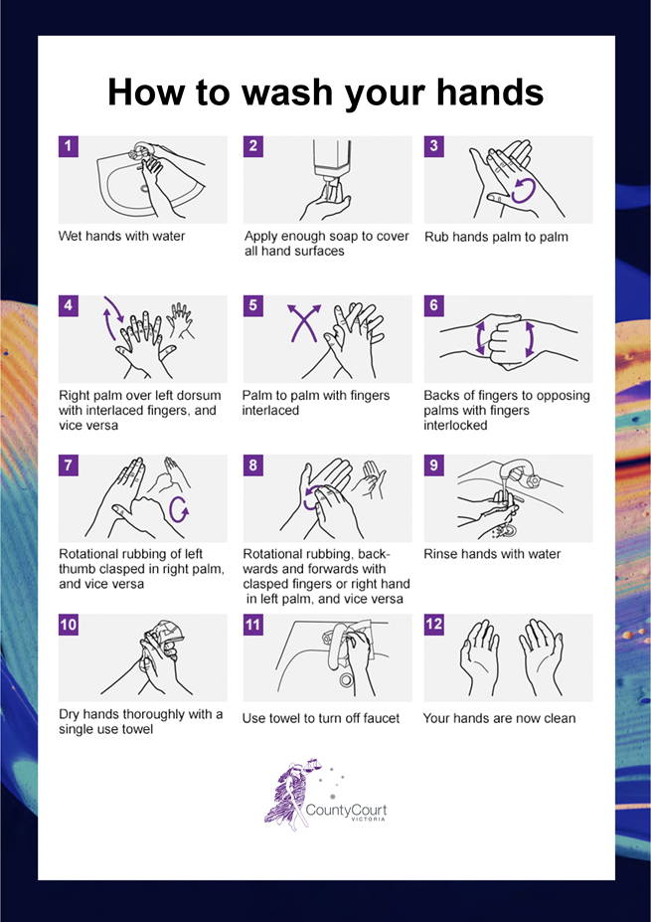

APPENDIX 2: Safe use of hand sanitiser protocol
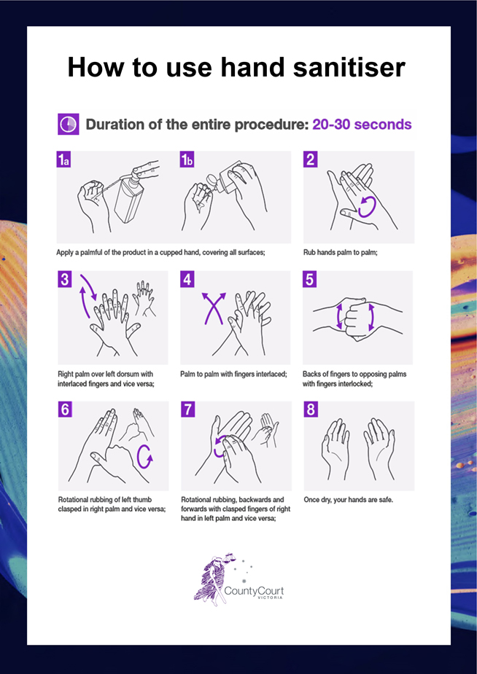

APPENDIX 3: Safe mask use and disposal protocol
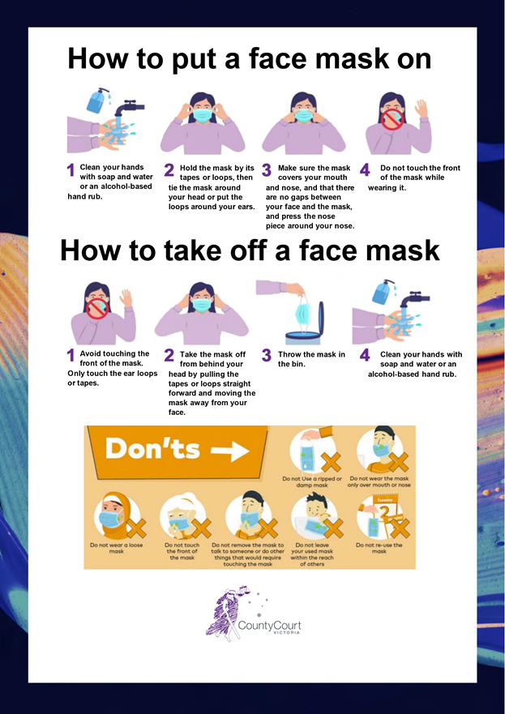
See ‘How to wear a mask’, Australian Government Department of Health: https://www.youtube.com/watch?v=rsBL0yTZNTM

APPENDIX 4: Safe glove use and disposal protocol
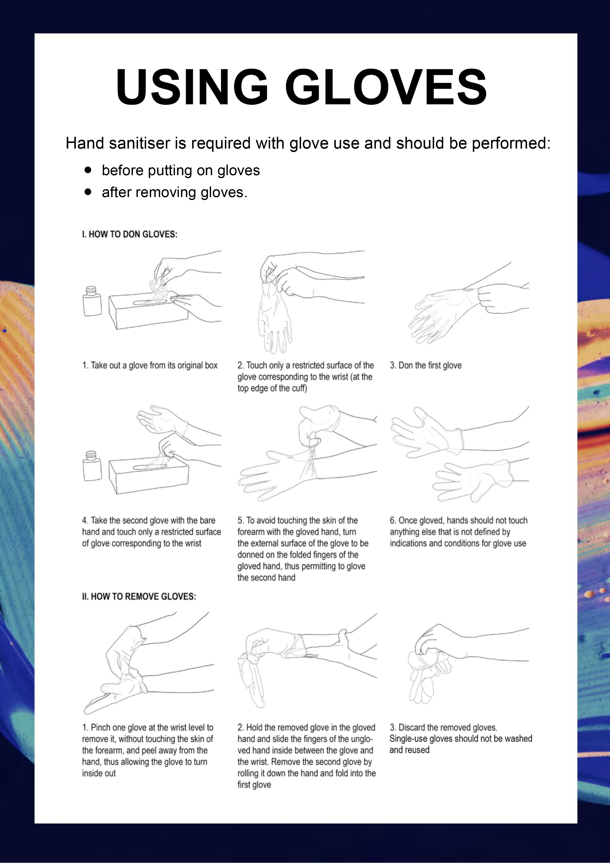
See Ansell’s video ‘How to properly remove single-use gloves’.

